Bhabha Homoeopathic Medical College & Hospital (LOGO n PHOTO of college building)
Empowering aspiring healthcare professionals through quality education, practical learning and a supportive academic environment.

Begin Your Journey in Homoeopathic Medicine

Where Education Meets Healing……
At Bhabha, we believe medical education is more than acquiring knowledge. It is about developing clinical understanding, professional skills and the compassion needed to care for people.
🎓 Learn — Build a strong foundation in medical knowledge
🏥 Experience — Connect learning with practical exposure
🌱 Grow — Develop professionally and personally
💙 Serve --- Compassionate patient care

Welcome to Bhabha Homoeopathic Medical College & Hospital
Bhabha Homoeopathic Medical College & Hospital is a centre for undergraduate education in Homoeopathic Medicine, located within the Bhabha University campus in Bhopal, Madhya Pradesh.
Our focus is on creating a strong foundation in Homoeopathic medical education while encouraging practical learning, clinical understanding and professional development. We strive to provide students with meaningful academic experiences, opportunities to learn in a hospital environment and an atmosphere that supports their overall growth.
With an academic environment supported by experienced faculty, teaching facilities and hospital-based clinical exposure, the college aims to prepare students for a meaningful and responsible career in Homoeopathic Medicine.
[Learn More About Us] | [Explore BHMS] | [Admissions 2026–27]

Why Choose Bhabha?
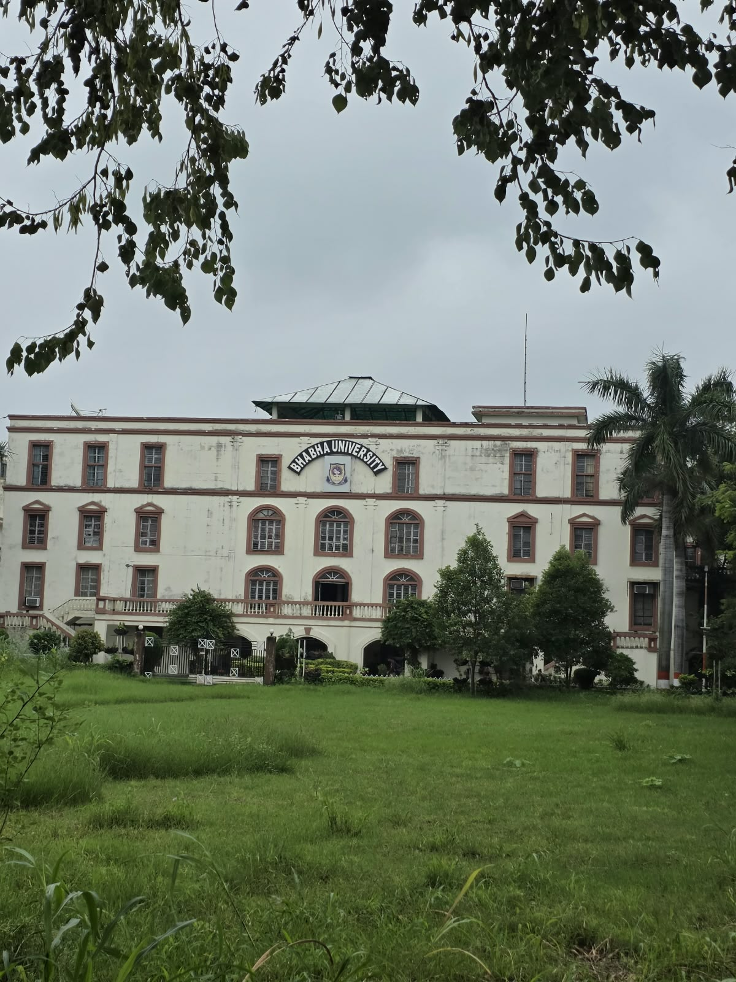

More Than Education — An Environment to Grow
Choosing a medical college is an important decision. At Bhabha, we aim to provide students with an environment that supports academic learning, practical development, clinical understanding and personal growth.
🎓 Strong Academic Foundation
Build a sound understanding of Homoeopathic medicine and the medical sciences through structured academic learning.
👩‍🏫 Dedicated Faculty
Learn with the guidance of faculty who support students throughout their academic and practical journey.
🏥 Hospital-Based Learning
Experience the connection between medical knowledge and patient care through hospital-based clinical learning.
🔬 Practical Approach
Strengthen understanding through practical sessions, demonstrations and hands-on learning opportunities.
🌿 Supportive Campus Environment
Study and grow in a campus environment that brings together academics, residential facilities and student activities.
🌱 Overall Student Development
Develop not only as a medical student, but also as a confident, responsible and compassionate healthcare professional.

Homepage — a small credibility strip, preferably below “Why Choose Bhabha?” or near the bottom, showing the three names/logos of recognition, affiliation)

Life at Bhabha
Learn. Participate and Celebrate. Achieve.
Life at Bhabha extends beyond the classroom. Students are encouraged to participate in academic activities, institutional events and celebrations that help them develop confidence, teamwork, communication skills and a sense of community.
- Learn
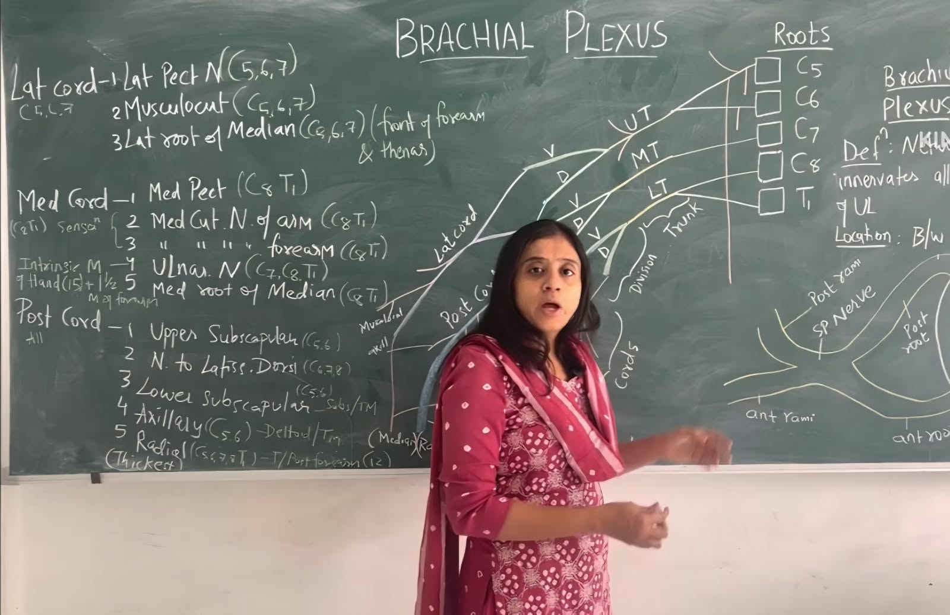
Engaging Academic Learning
Interactive teaching that encourages students to understand concepts and participate actively in their learning.

- Participate
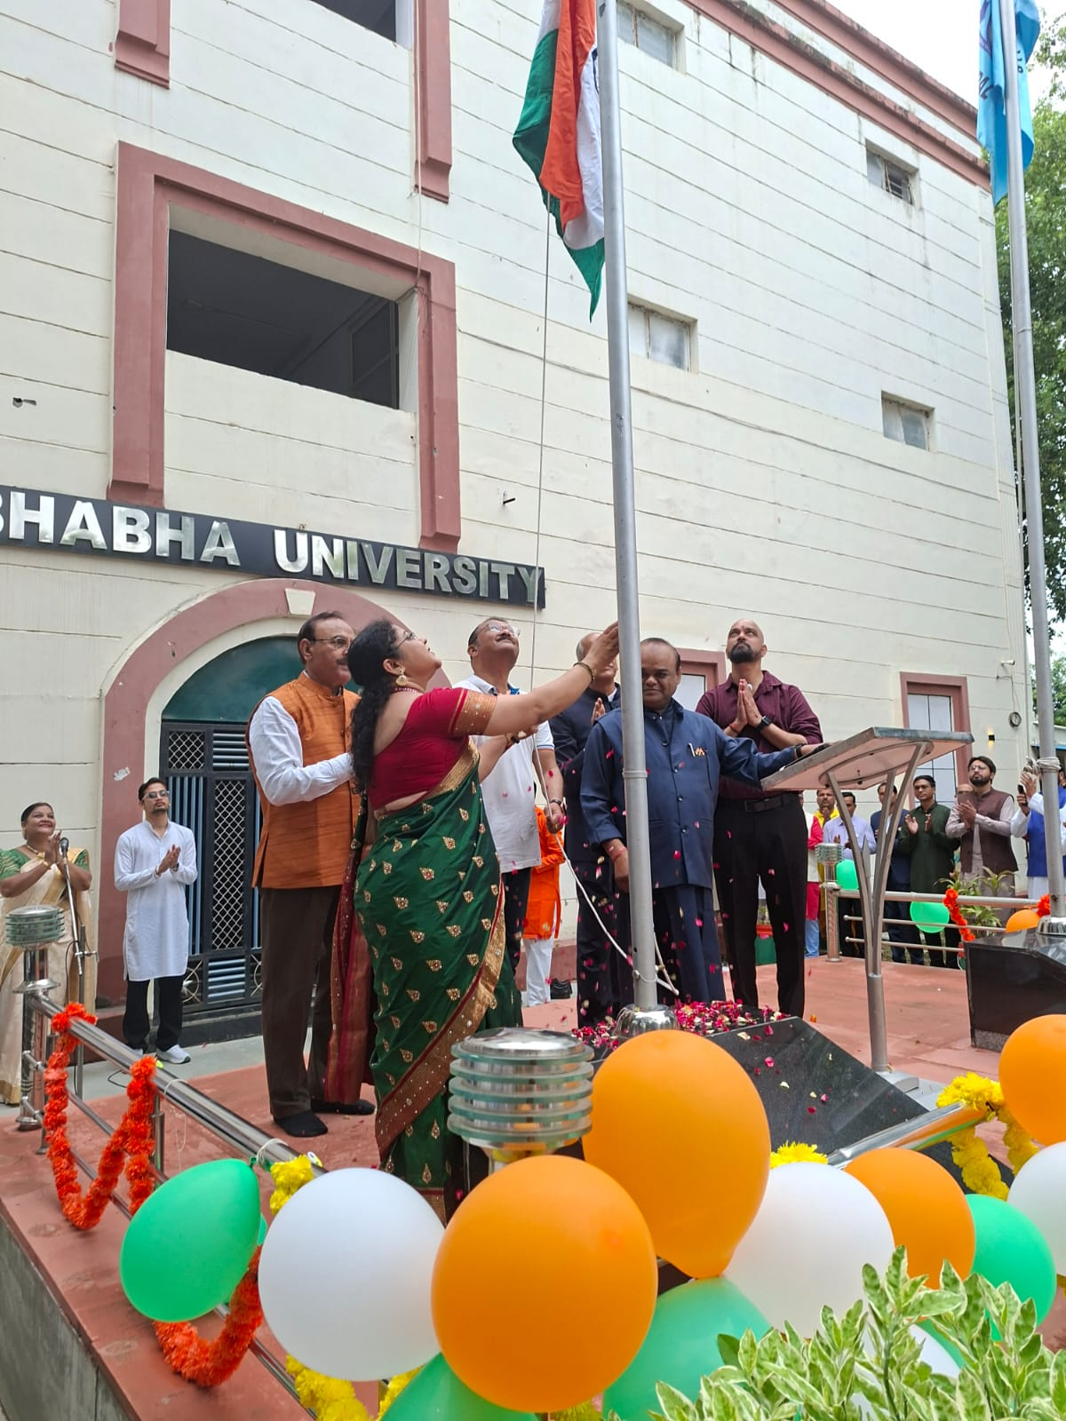

Participating and Celebrating Together
Students and faculty come together to celebrate important occasions and build a strong sense of community.

- Achieve

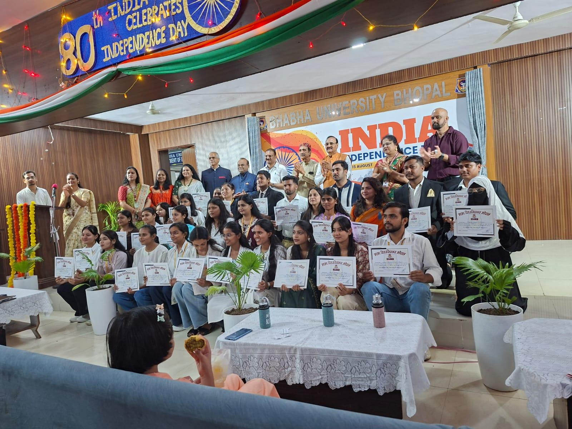
Recognising Student Achievements
Celebrating the efforts, participation and accomplishments of our students.

Admission 2026-27
YOUR JOURNEY STARTS HERE
Take the first step towards a career in Homoeopathic Medicine.
01 — EXPLORE
Discover BHMS and what Bhabha offers.
02 — ENQUIRE
Get guidance about eligibility, admission process and the course.
03 — JOIN
Take the next step towards becoming part of the Bhabha family.
Then the buttons:
[ Admission Details ]
[ Enquire Now ]
[ Contact Admission Team ]

Extra pictures
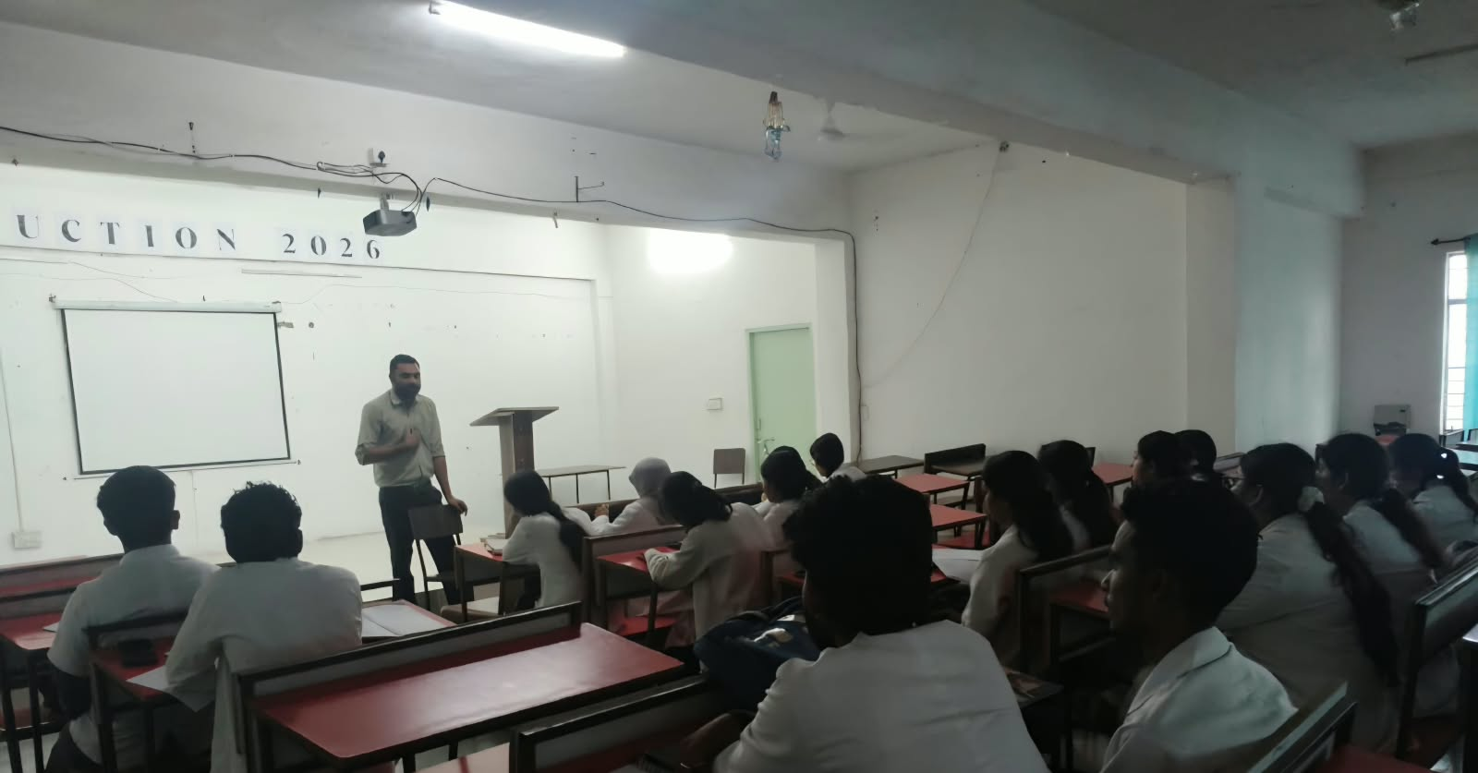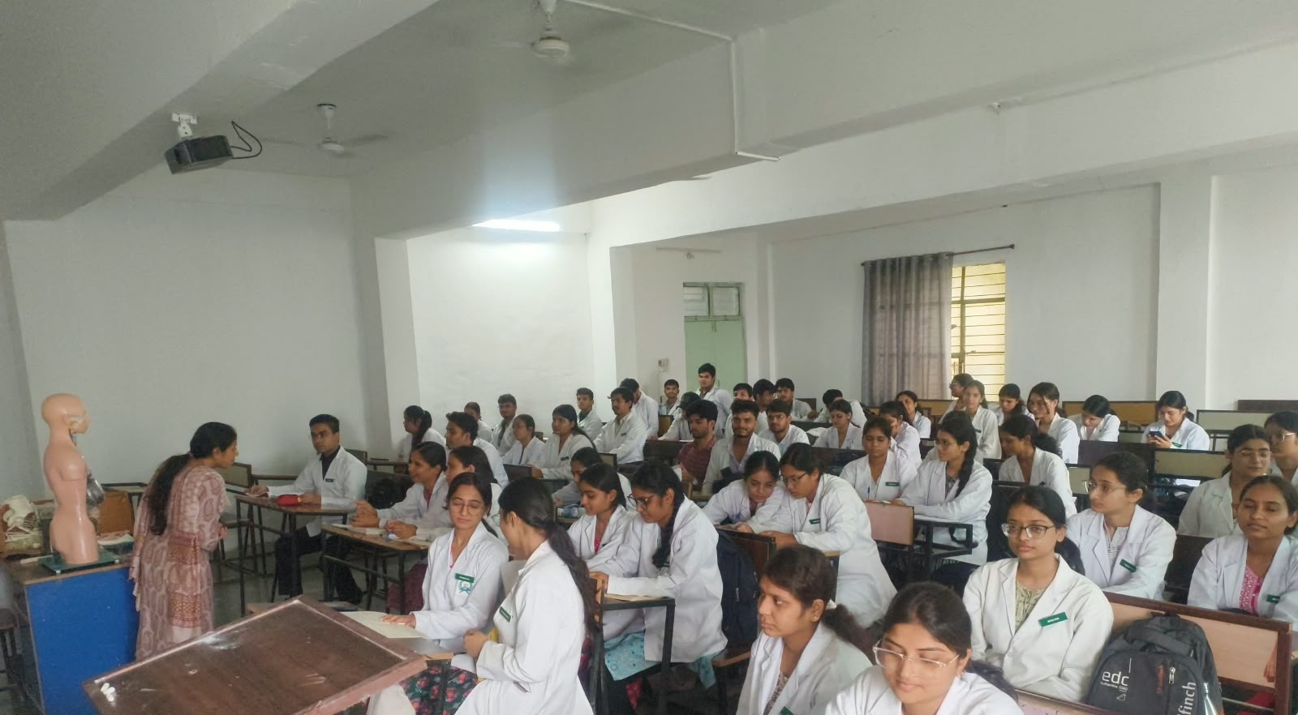

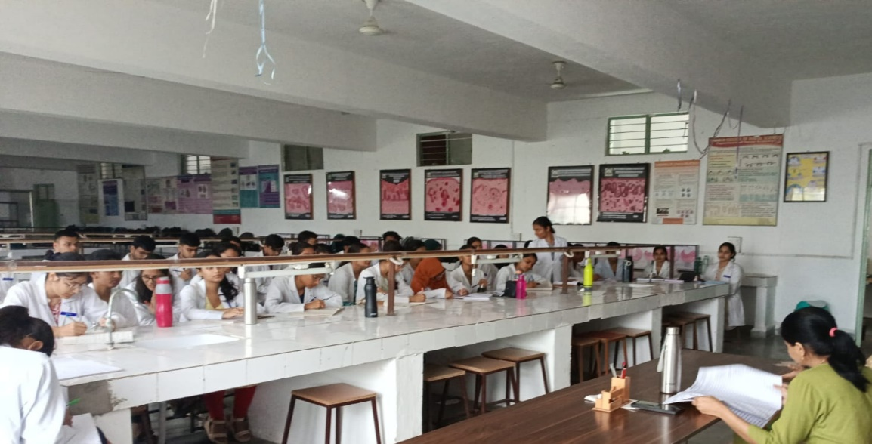

(Footer contact no.)
BHABHA HOMOEOPATHIC MEDICAL COLLEGE & HOSPITAL
Bhabha University Campus
Jatkhedi, NH-12, Hoshangabad Road
Bhopal, Madhya Pradesh – 462026
Admissions
📞 Admission Enquiry:
[University: 0755-4246498
Admission: 7974846908, 9039921140
Email: info@bhabhauniversity.edu.in / bhabhauniversitybpl@gmail.com

About the College
Academics
Hospital
Campus & Facilities
Admissions
Contact
Connect with us on [Facebook] [Instagram] [YouTube]
📍 View Campus on Google Maps

(HOMEPAGE ENDS HERE)

Next tab
ABOUT US/BHMCH

Bhabha Homoeopathic Medical College & Hospital is committed to providing quality undergraduate education in Homoeopathic Medicine in an environment that encourages academic excellence, practical learning, clinical understanding and professional development.
Located within the Bhabha University campus at Jatkhedi, Bhopal, the college aims to provide students with a strong foundation in medical sciences and Homoeopathic education, complemented by practical and hospital-based learning experiences.
We strive to nurture knowledgeable, skilled and compassionate healthcare professionals who approach patient care with competence, empathy and professional responsibility.

(Recognition and Affiliation}

Our Vision (with Image as on homepage)
To foster excellence in Homoeopathic medical education and nurture competent, compassionate and responsible healthcare professionals committed to serving society.

Our Mission (image as on homepage)
To provide a strong foundation in medical sciences and Homoeopathic education.
To integrate classroom teaching, practical learning and clinical experience.
To encourage critical thinking, professional competence and lifelong learning.
To promote ethical values, empathy and responsible patient care.
To provide an environment that supports the academic, professional and personal development of students.

Our Educational Approach
Learning Beyond the Classroom
At Bhabha Homoeopathic Medical College & Hospital, education is approached as a combination of knowledge, practical learning and clinical understanding.
Our academic approach aims to help students develop a strong foundation in medical sciences and Homoeopathic medicine while gradually building the skills and professional confidence required for patient care.
Four pillars of our educational approach
📚 Learn
Build a strong foundation through structured teaching of medical sciences and Homoeopathic subjects.
🔬 Practise
Reinforce concepts through practical sessions, demonstrations and laboratory-based learning.
🏥 Experience
Connect academic knowledge with clinical situations through hospital-based learning and patient interaction.
🌱 Develop
Build communication, professional ethics, empathy, confidence and a commitment to lifelong learning.
We believe that meaningful medical education develops not only knowledgeable students, but responsible healthcare professionals.

A Message from the Principal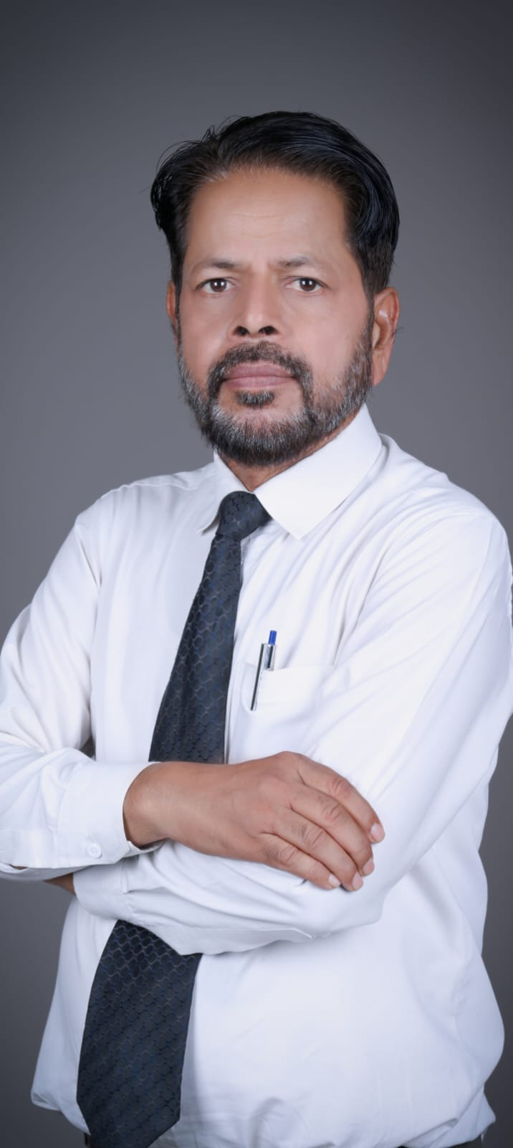
Dear Students, Faculty Members and Parents,
It is my pleasure to welcome you to Bhabha Homoeopathic Medical College & Hospital and to invite you to be a part of an educational environment dedicated to learning, professional development and service.
Homoeopathy has a long tradition of individualized healthcare, with an emphasis on understanding the patient as a whole. At Bhabha, we aim to nurture this philosophy alongside sound medical education, practical learning and clinical experience.
Our endeavour is to provide students with opportunities to develop knowledge, clinical understanding, professional skills and the values of empathy and compassion. We encourage our students to approach their education with curiosity, discipline and a commitment to lifelong learning.
As future healthcare professionals, our students have an important role in contributing to the health and well-being of society. We strive to prepare them not only for their professional responsibilities but also for a life of service, integrity and continued learning.
I warmly welcome all aspiring students to begin their educational journey with us.
With best wishes for your success and a fulfilling professional journey,
Dr. Ahmed Dad Khan
DHMS, PGD in G & C (BU)
Principal
Bhabha Homoeopathic Medical College & Hospital
NEXT TAB
ACADEMICS
- BHMS Programme Curriculum
- Departments & Faculty
- Job Opportunities

(1,2,3 are dropdown list)

Programmes Offered
B.H.M.S. (Bachelor of Homoeopathic Medicine & Surgery)
A Comprehensive Undergraduate Programme in Homoeopathic Medicine
The Bachelor of Homoeopathic Medicine and Surgery (BHMS) is an undergraduate medical programme that combines fundamental medical sciences, Homoeopathic education, practical training and clinical experience.

At Bhabha Homoeopathic Medical College & Hospital, the programme is designed to provide students with a strong foundation in medical sciences and Homoeopathic principles while developing clinical understanding, practical skills, professional competence and ethical values.

PROGRAMME AT A GLANCE
Degree: Bachelor of Homoeopathic Medicine and Surgery (BHMS)
Level: Undergraduate
Duration: 5½ Years
Internship: One-Year Rotatory Internship
Mode: Full-Time
Recognition:
Recognised under the regulatory framework of the National Commission for Homoeopathy (NCH) & Ministry of AYUSH
Affiliation:
Bhabha University, Bhopal
ABOUT THE BHMS PROGRAMME
BHMS is a comprehensive undergraduate programme that brings together the study of human anatomy and physiology, basic medical sciences, Homoeopathic philosophy and therapeutics, clinical subjects and patient care.
The programme progresses from foundational medical sciences to Homoeopathic subjects and clinical education, enabling students to gradually develop the knowledge and skills required for professional practice.

WHAT STUDENTS LEARN
1. MEDICAL SCIENCES
Students develop a strong understanding of the structure and functioning of the human body through subjects including:
* Anatomy
* Physiology & Biochemistry
* Pathology & Microbiology
* Forensic Medicine & Toxicology

2. HOMOEOPATHIC SCIENCES
Students are introduced to the principles, philosophy and practical application of Homoeopathy through:
* Homoeopathic Pharmacy
* Homoeopathic Materia Medica
* Organon of Medicine
* Homoeopathic Repertory & Case Taking

3. CLINICAL SCIENCES
Students develop clinical knowledge and understanding through subjects including:
* Practice of Medicine
* Surgery
* Obstetrics & Gynaecology
* Paediatrics
* Community Medicine & Research Methodology
* Yoga & Physiotherapy

LEARNING THROUGH PRACTICAL EXPERIENCE
The BHMS programme goes beyond classroom teaching.
Students are provided opportunities for practical learning through:
* Cadaveric Dissection
* Osteology and Histology
* Laboratory-Based Learning
* Pharmaceutical Practical Training
* Case Taking and Repertorisation
* Clinical Demonstrations
* OPD-Based Clinical Learning
* IPD-Based Clinical Learning
* Community-Based Learning
* Skills-Based Training

CLINICAL EDUCATION
Clinical education forms an important part of the BHMS programme.
Through the attached teaching hospital, students gain exposure to patient care and clinical learning under the guidance of faculty.
Students are progressively introduced to:
* Patient History and Case Taking
* General Physical Examination
* Clinical Observation
* Case Analysis
* Repertorisation
* Clinical Correlation
* Patient Counselling
* Follow-up and Documentation
Clinical learning provides students with an opportunity to connect theoretical knowledge with real-world patient care.

ROTATORY INTERNSHIP
The BHMS programme includes a mandatory one-year rotatory internship.
The internship provides students with an opportunity to further develop their clinical skills and professional competence through supervised practical and clinical experience.
It serves as an important transition from undergraduate education towards professional practice.

BHMS CURRICULUM
The Bachelor of Homeopathic Medicine and Surgery (BHMS) is an undergraduate degree divided into four professional years under the National Commission for Homoeopathy curriculum.
First Year BHMS
- Anatomy, Histology and Embryology: Study of human body structure, tissues, and development.

- Human Physiology and Bio-chemistry: Study of life processes, cellular functions, and chemical processes in the body.

- Homoeopathic Pharmacy: Principles of preparing and dispensing homeopathic medicines.

- Homoeopathic Materia Medica: Introduction to properties and profiles of homeopathic remedies.

- Organon of Medicine, Homoeopathic Philosophy and Fundamentals of Psychology: Basic principles and philosophical foundations of homeopathy alongside human behavior.

- Homoeopathic Repertory and Case Taking: Methods of taking patient histories and indexing symptoms.

- Yoga for Health Promotion: Basic yoga practices integrated into health and wellness. (https://nch.org.in/first-bhms)

Second Year BHMS
- Pathology and Microbiology: Study of diseases, parasites, bacteriology, and virology.
- Forensic Medicine and Toxicology: Medical ethics, legal responsibilities, and poisons.
- Homoeopathic Materia Medica: Expanded study of drug pictures and remedy relationships.
- Organon of Medicine and Homoeopathic Philosophy: Deeper exploration of homeopathic doctrine.
- Surgery, Gynaecology, and Obstetrics (along with Homoeo-therapeutics): General surgical principles and women's health.
- Practice of Medicine: Clinical diagnostics and general medicine.
(https://nch.org.in/second-bhms)

Third Year BHMS
- Surgery and Homoeo-therapeutics: Surgical conditions, ENT, ophthalmology, dentistry, and their homeopathic treatment.
- Gynaecology and Obstetrics: Advanced study of reproductive health, child birth, and infant care.
- Homoeopathic Materia Medica: Advanced remedy study and comparative materia medica.
- Organon of Medicine: Chronic diseases and advanced philosophical principles.
- Repertory: Advanced repertorization techniques.
- Practice of Medicine: Systematic study of clinical diseases and medical therapeutics.

Fourth Year BHMS
- Practice of Medicine and Homoeo-therapeutics: Comprehensive clinical medicine, patient management, and treatment.
- Homoeopathic Materia Medica: Complete mastery of drug profiles and clinical application.
- Organon of Medicine and Homoeopathic Philosophy: Advanced case analysis and holistic management.
- Case Taking and Repertory: Practical application of repertories in complex chronic cases.
- Community Medicine (Preventive and Social Medicine): Public health, sanitation, epidemiology, and preventive medicine.
(https://nch.org.in/fourth-bhms)National Commission for Homoeopathy (NCH)

Departments & Faculty
- Department of Anatomy
Faculty of Anatomy
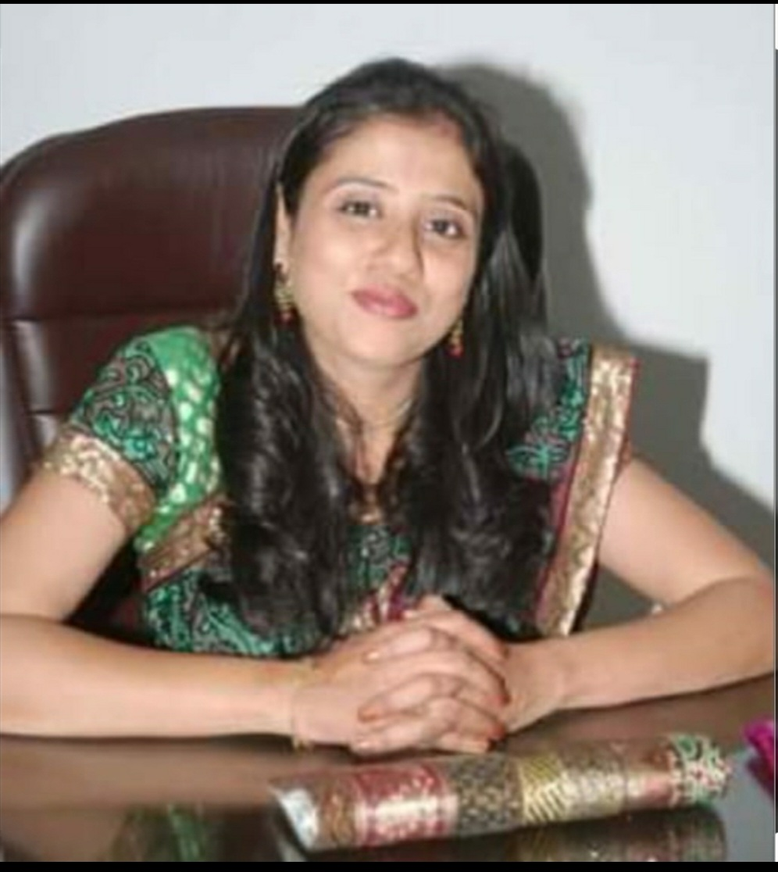

Name- Dr. Tasneem Amir Hussain
Designation- Associate Professor
Department- Department of Human Anatomy
Qualification- BHMS, MD( Hom), BPT
Experience- 4.10 years of Teaching Experience and 24 years of Clinical Practice.
Achievements-Actively participated in Covid Research Programme held in Government Homoeopathic Medical College and Hospital , Bhopal, in 2020
Ex Co-editor of NewLife Era, A Homoeopathic Journal.
Running a Youtube Channel on Subject of Anatomy, with commitment to excellence in Teaching and student development
HUMAN ANATOMY
Understanding the Structure of the Human Body
The Department of Anatomy provides students with a strong foundation in the structural organisation of the human body. Through systematic study of gross anatomy, microscopic anatomy and developmental anatomy, students develop an understanding of the structures that form the basis of normal human function and clinical practice.
The department emphasises conceptual understanding through classroom teaching, practical demonstrations and three-dimensional appreciation of anatomical structures, helping students connect anatomical knowledge with its clinical relevance.

Practical Learning in Anatomy
Our practical teaching focuses on developing a clear, three-dimensional understanding of the human body through:
🧑‍⚕️ Cadaveric Dissection
Students gain hands-on experience through dissection of cadavers, enabling them to study anatomical structures, their relationships and their spatial orientation directly.
🦴 Osteology
Systematic study of bones helps students understand the structure, landmarks, articulations and anatomical relationships of the skeletal system, with emphasis on identification through practical examination.
🔬 Histology
Microscopic study of tissues and organs helps students correlate their microscopic structure with their normal function.
🔹 Embryology
Learning the development of the human body from conception to birth.
🩺 Clinical Anatomy
Anatomical knowledge is related to clinical examination and its application in medical practice.

Anatomy in Practice
Cadaveric Dissection | Osteology | Histology | Practical Learning

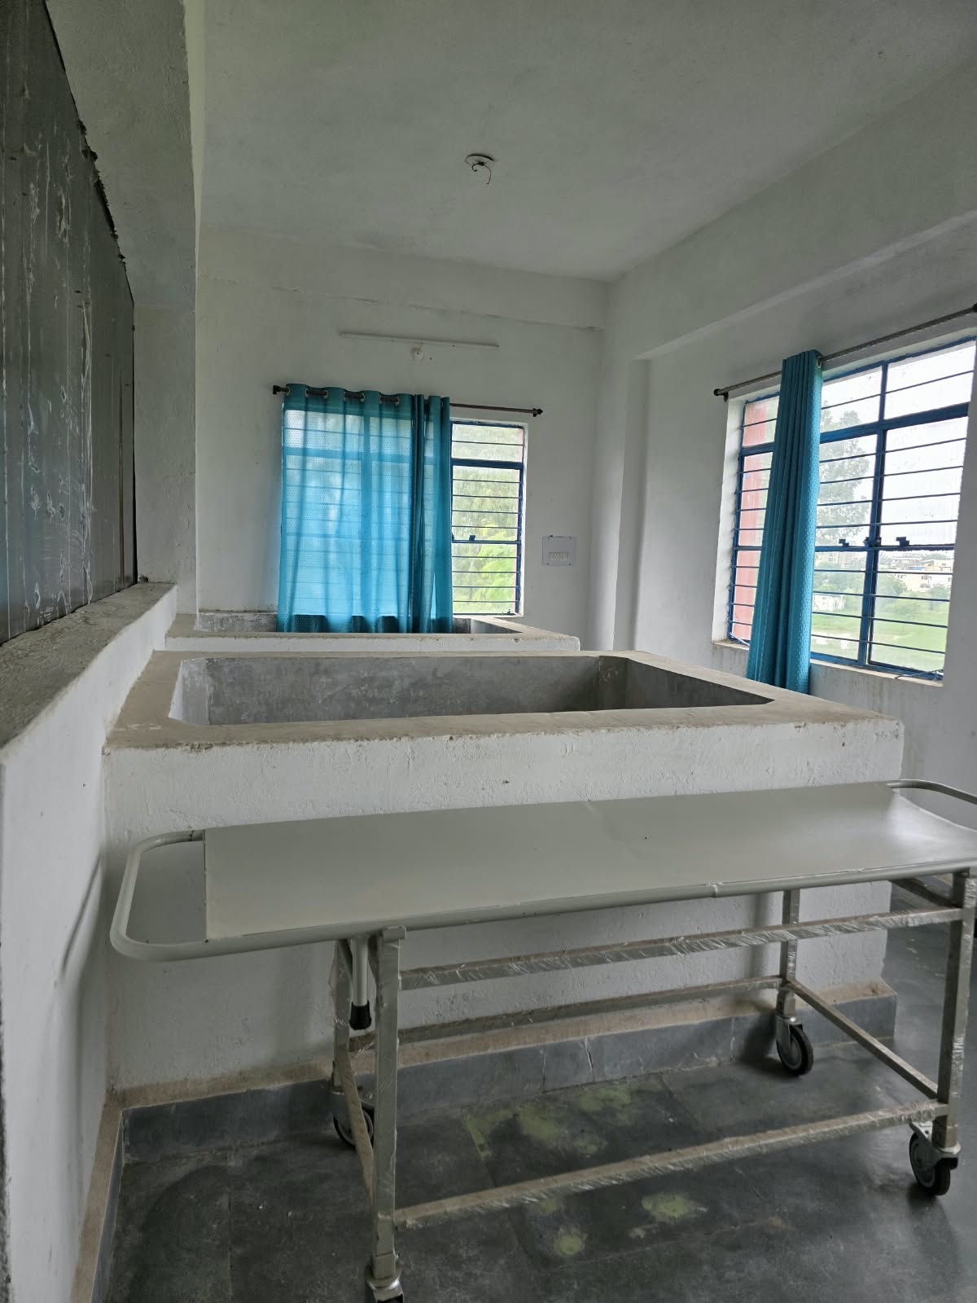
Cadaver room

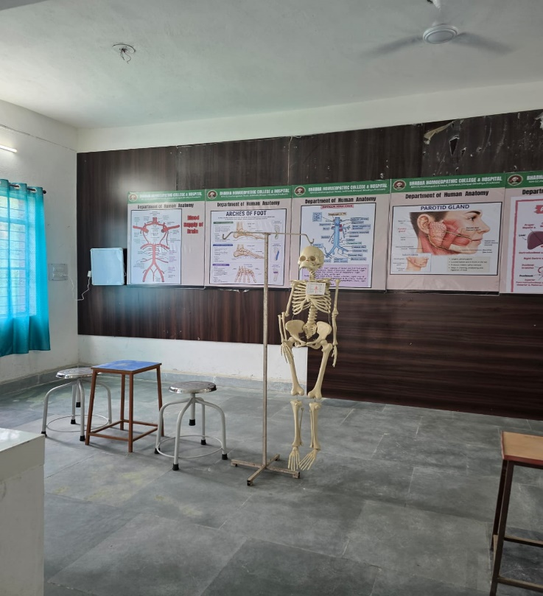
Skeleton in the anatomy museum

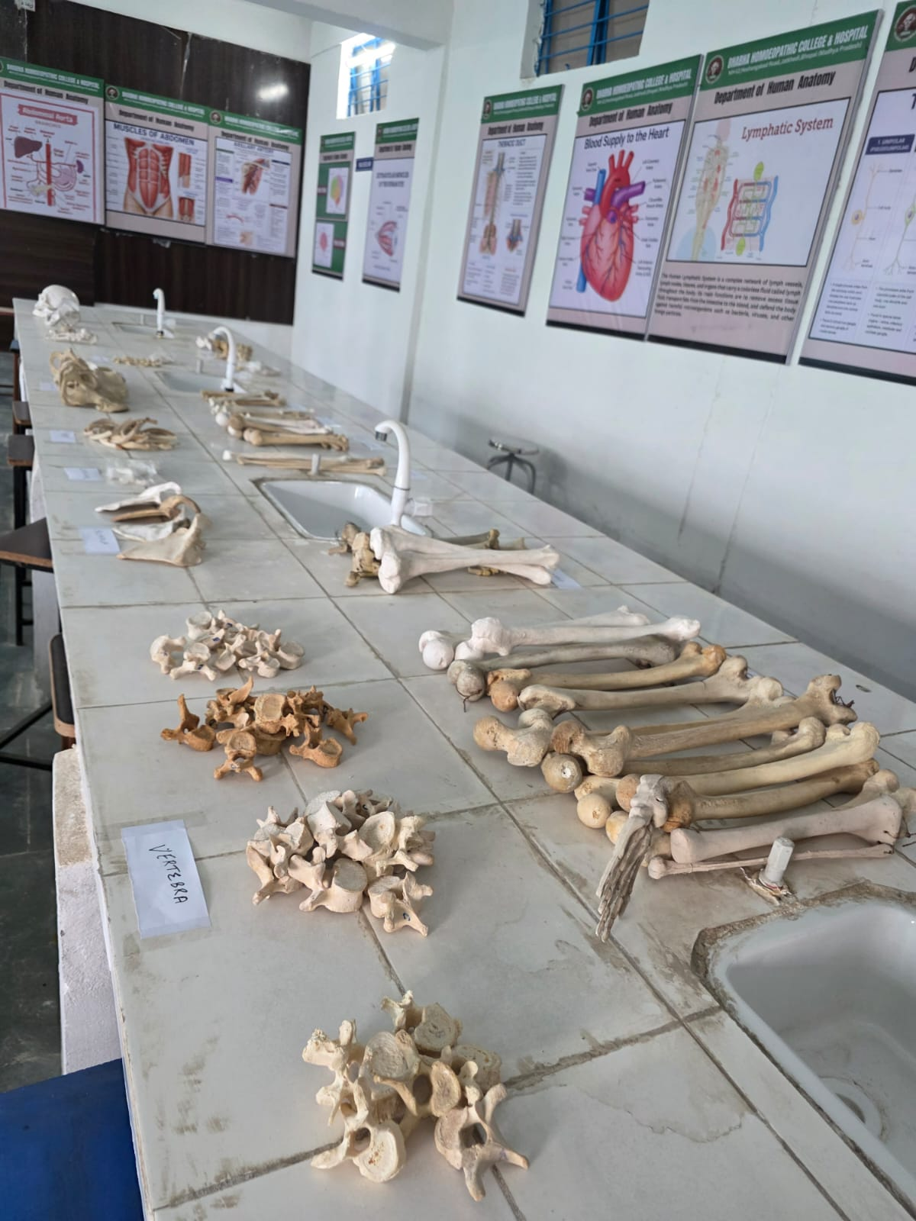
Osteology (Study of Bones)

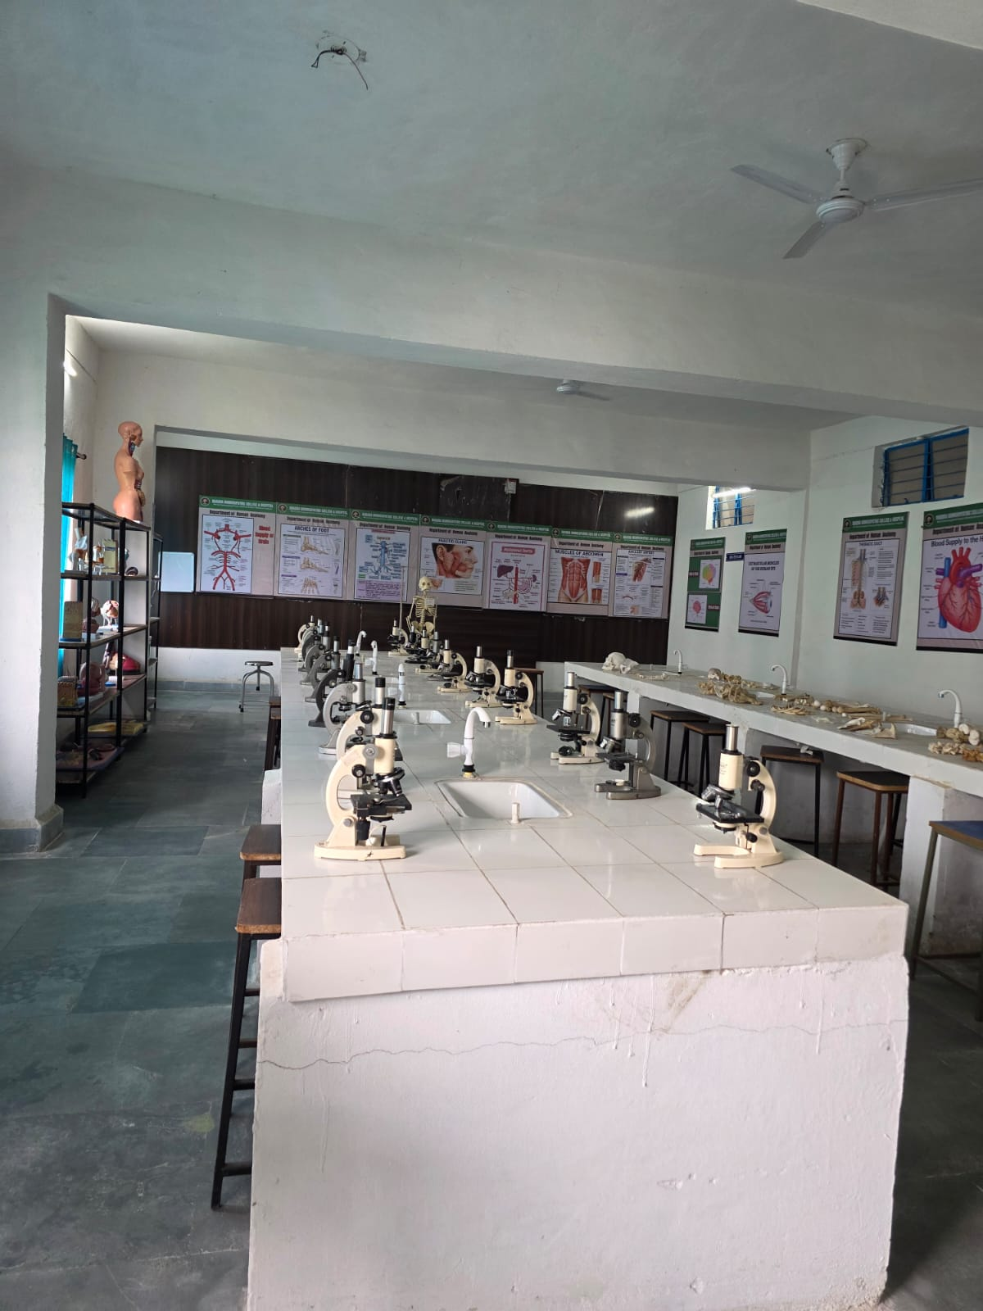
Histology (Microscopic study of anatomy)
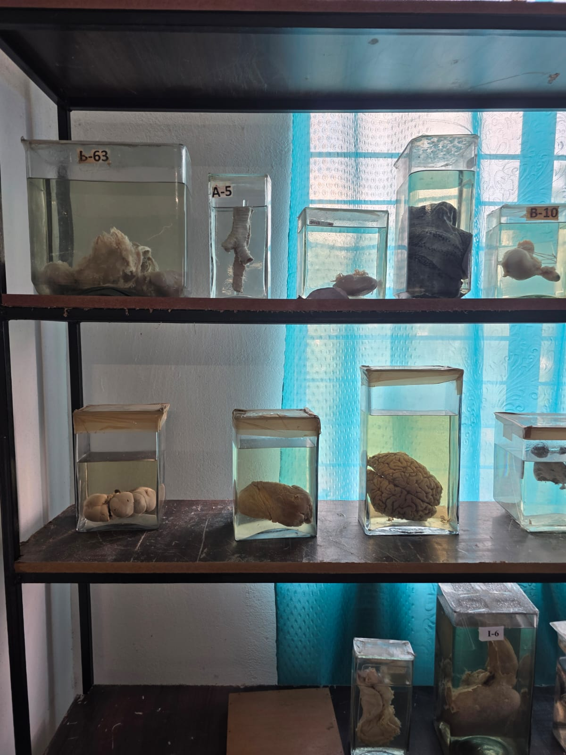
Soft tissue specimens

- DEPARTMENT OF PHYSIOLOGY & BIOCHEMISTRY

Faculty of Physiology

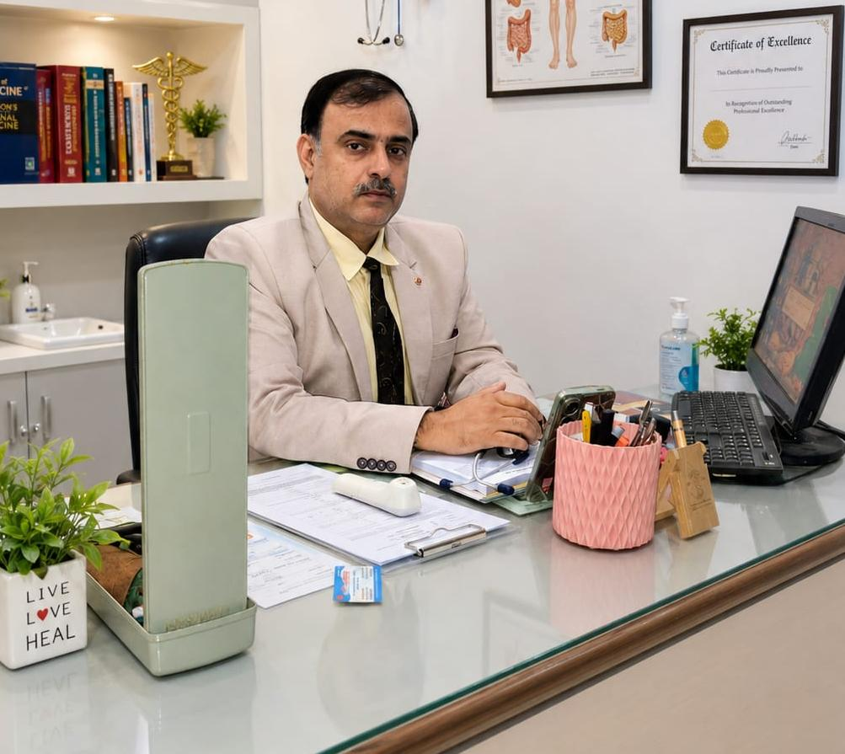

Name: Dr. Harish Kumar Tuli
Designation: Professor & HOD
Department: Human Physiology & Biochemistry
Qualification: BHMS, MD (HOM)
Experience: 21 years of Teaching Experience.
Achievements: Research in LM Potency Efficacy in Essential Hypertension

PHYSIOLOGY & BIOCHEMISTRY
Understanding the Functions and Processes of the Human Body
The Department of Physiology & Biochemistry provides students with a strong foundation in understanding the normal functions of the human body and the biochemical processes that support life.

The department helps students understand how the different systems of the body function individually and work together to maintain health and internal balance. This knowledge forms an essential foundation for understanding disease processes and clinical subjects.

WHAT STUDENTS LEARN
General Physiology
Students learn the fundamental principles governing normal body functions, including homeostasis and the mechanisms that maintain the internal environment.

Blood and Body Fluids
Study of the composition and functions of blood and body fluids, including haematological parameters and their physiological significance.

Nerve and Muscle Physiology
Understanding the structure and functional properties of nerve and muscle tissue, including nerve conduction and neuromuscular function.

Cardiovascular System
Study of the normal functioning of the heart and circulation, including cardiac cycle, cardiac output, blood pressure and regulation of the cardiovascular system.

Respiratory System
Understanding the mechanisms of respiration, pulmonary ventilation, gas exchange and regulation of breathing.

Digestive System
Study of gastrointestinal functions, digestion, absorption and regulation of digestive processes.

Renal Physiology
Understanding kidney function, urine formation, fluid and electrolyte balance and maintenance of acid-base balance.

Endocrine and Reproductive Physiology
Study of hormonal regulation, endocrine functions and the physiological processes involved in human reproduction.

Central Nervous System
Understanding the functional organisation of the nervous system, sensory and motor functions and higher nervous activities.

BIOCHEMISTRY
Students are introduced to the biochemical basis of normal body functions, including carbohydrates, proteins, lipids, enzymes, vitamins, minerals, nucleic acids and metabolism.

PRACTICAL LEARNING
Practical teaching helps students understand physiological processes through demonstrations and laboratory-based exercises. Students are encouraged to observe, record and interpret physiological parameters and relate their findings to normal human function.
Practical learning may include basic haematological investigations, examination of physiological parameters and demonstrations related to cardiovascular, respiratory and other body systems.

CLINICAL CORRELATION
The department emphasises the clinical relevance of physiology and biochemistry, helping students understand how knowledge of normal body functions provides the foundation for recognising and understanding abnormalities encountered in clinical subjects.

OUR APPROACH
The department aims to develop a clear understanding of normal human physiology and the biochemical processes underlying health, enabling students to build a strong foundation for pathology, pharmacology and subsequent clinical learning.

LEARNING THROUGH PHYSIOLOGY & BIOCHEMISTRY
Understand | Observe | Experiment | Analyse | Correlate
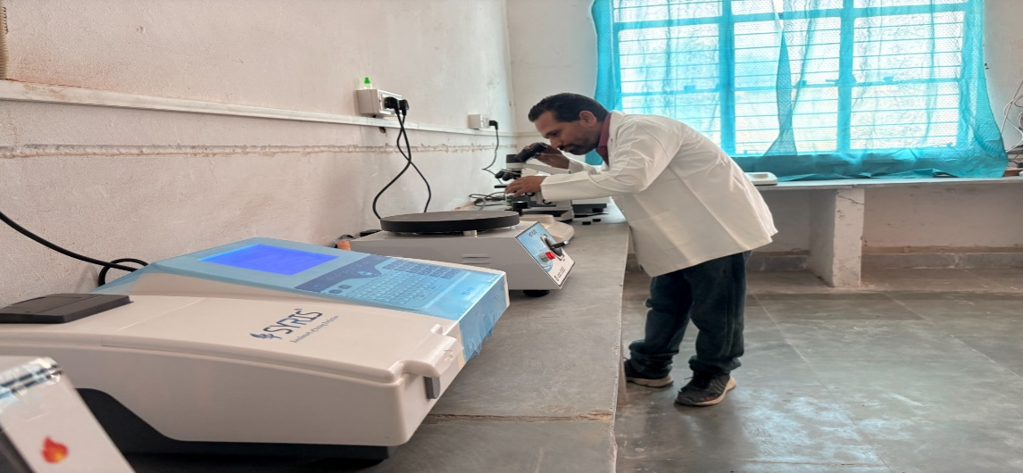

- Department of Homoeopathic Pharmacy
Faculty of Pharmacy
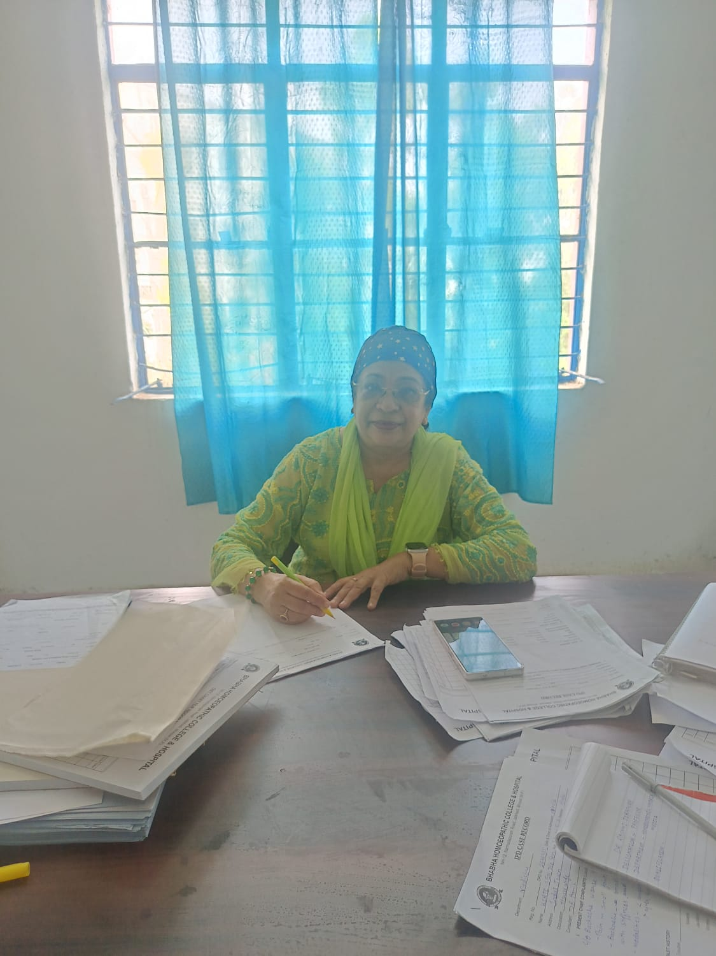
Name: Dr. Anees Fatema
Designation: Professor
Qualification: MD (HOM)
Experience: 34 years
Research & Publication: Publication in International Journal Of Pharmacy with Medical Sciences and American Journal of Management and IOT Medical Computing
Achievements: Resource person in CME at State BrijKishore Medical college at Faizabad, UP.
Chairperson Board of Studies at Bhakta Kavi Narsinh Mehta University, Junagadh, Guj.

HOMOEOPATHIC PHARMACY
Understanding Homoeopathic Medicines
The Department of Homoeopathic Pharmacy introduces students to the principles and practices involved in the preparation, handling, storage and dispensing of Homoeopathic medicines. The department aims to develop a clear understanding of pharmaceutical concepts while connecting them with the principles and practice of Homoeopathy.
What Students Learn
🌿 Homoeopathic Pharmaceutical Principles
Understanding the basic principles and concepts underlying Homoeopathic pharmacy.
⚗️ Preparation of Medicines
Learning the methods used for the preparation of Homoeopathic pharmaceutical preparations, including mother tinctures, triturations, dilutions and potentisation.
🧪 Practical Pharmacy
Students gain practical exposure to pharmaceutical procedures, preparation techniques and appropriate handling of Homoeopathic medicines.
📦 Storage & Dispensing
Understanding proper storage, identification, labelling and dispensing of Homoeopathic medicines.
🔬 Identification of Crude Drugs
Learning about the sources and identification of substances used in Homoeopathic pharmacy.
Practical Learning
Practical teaching forms an important part of the department. Students are encouraged to understand pharmaceutical procedures through demonstrations and hands-on practical work, helping them connect theoretical concepts with actual preparation and handling of medicines.

Our Approach
The department strives to develop accuracy, scientific understanding and practical competence in students, providing them with the pharmaceutical foundation required for their subsequent Homoeopathic education and professional practice.

Pharmacy in Practice
Drug Identification | Trituration | Potentisation | Pharmaceutical Preparations

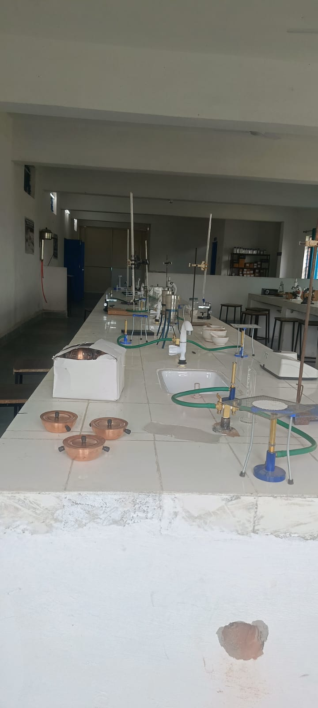

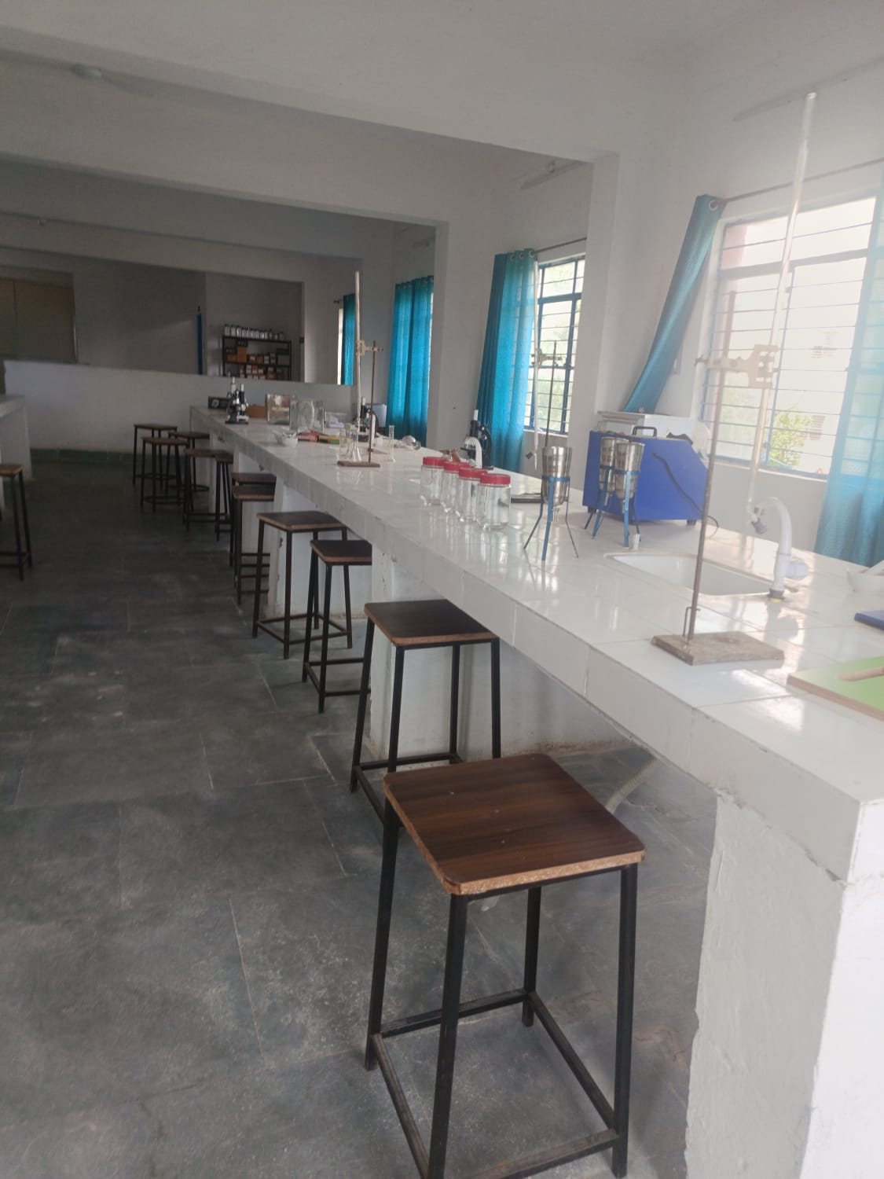
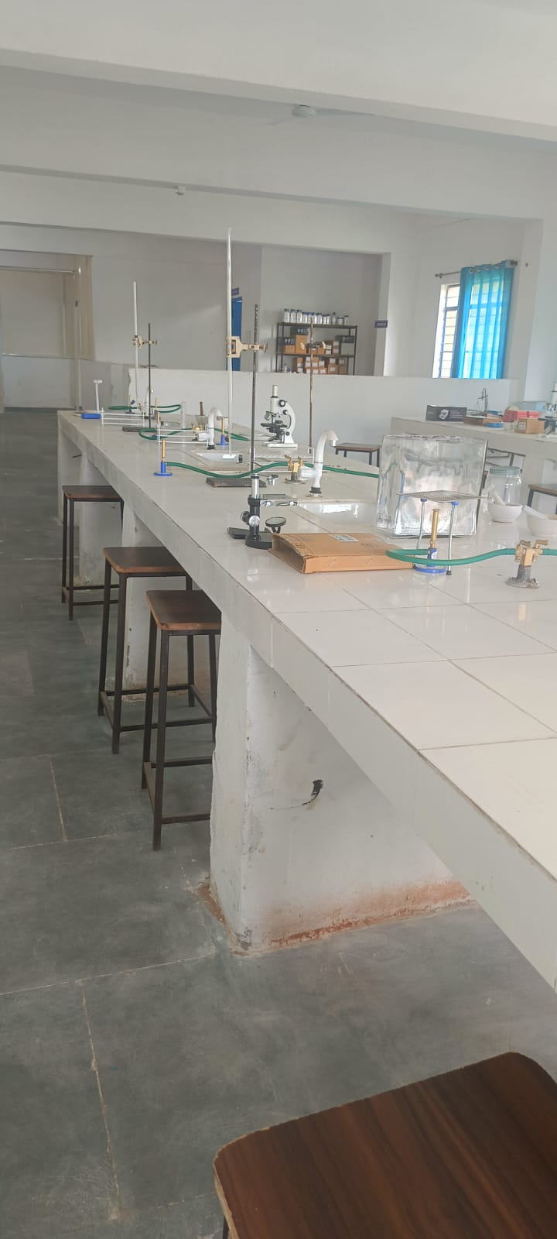

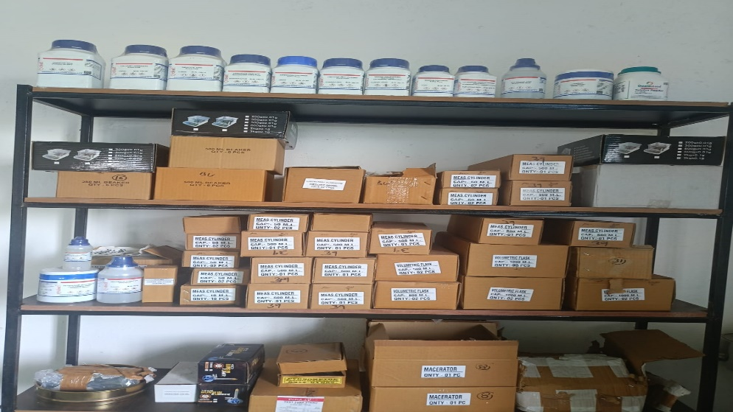

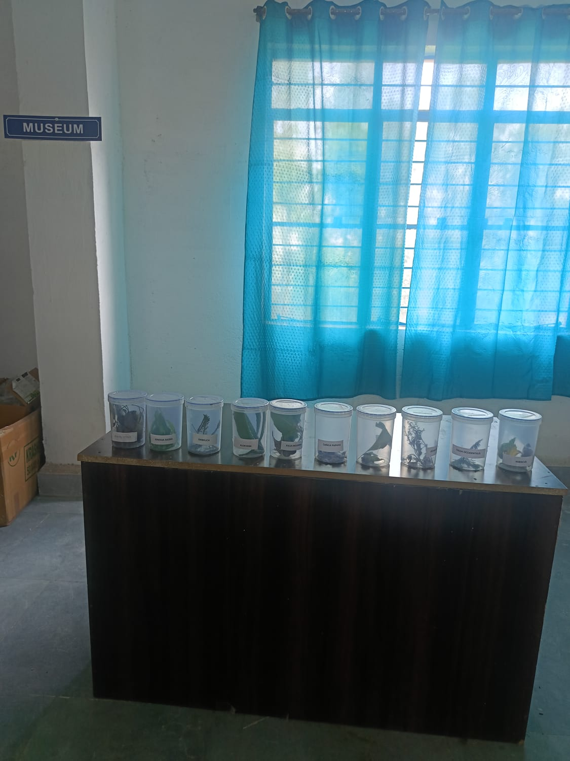

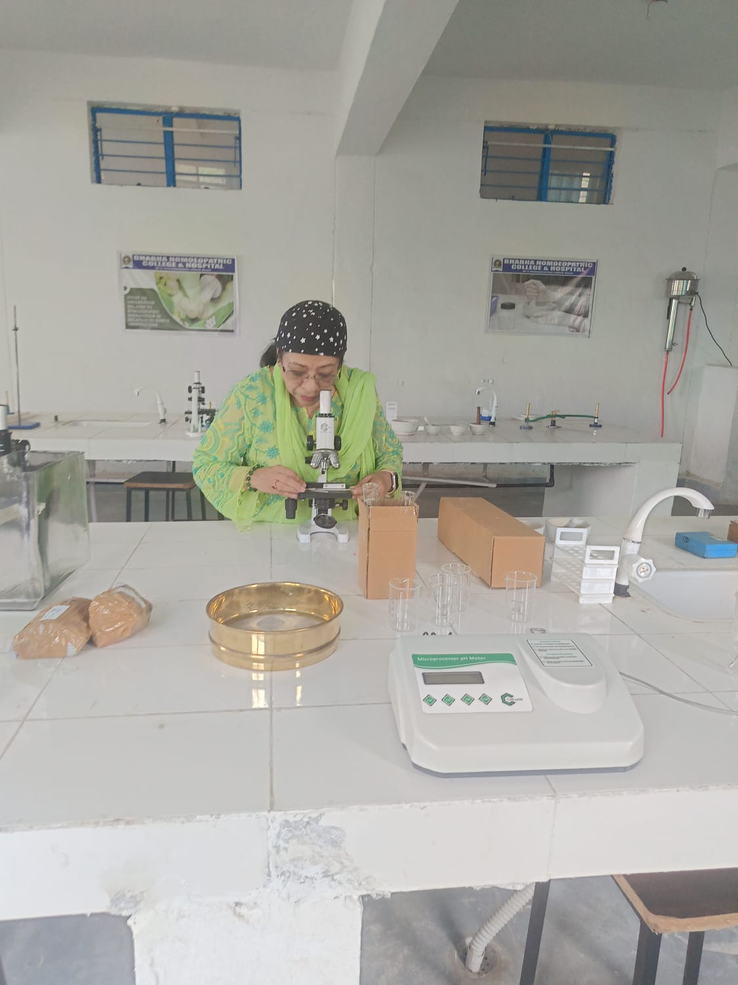

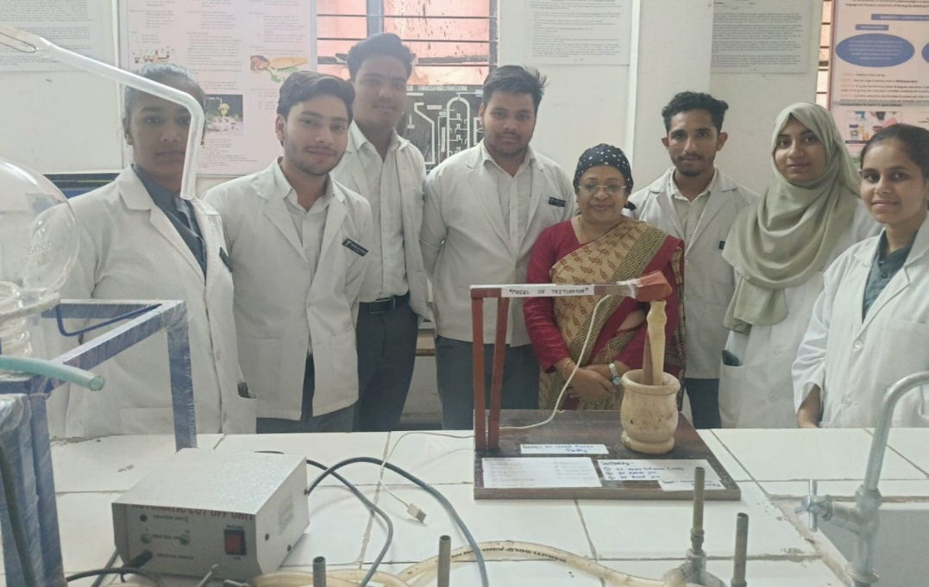

- DEPARTMENT OF HOMOEOPATHIC MATERIA MEDICA

Faculty of materia medica

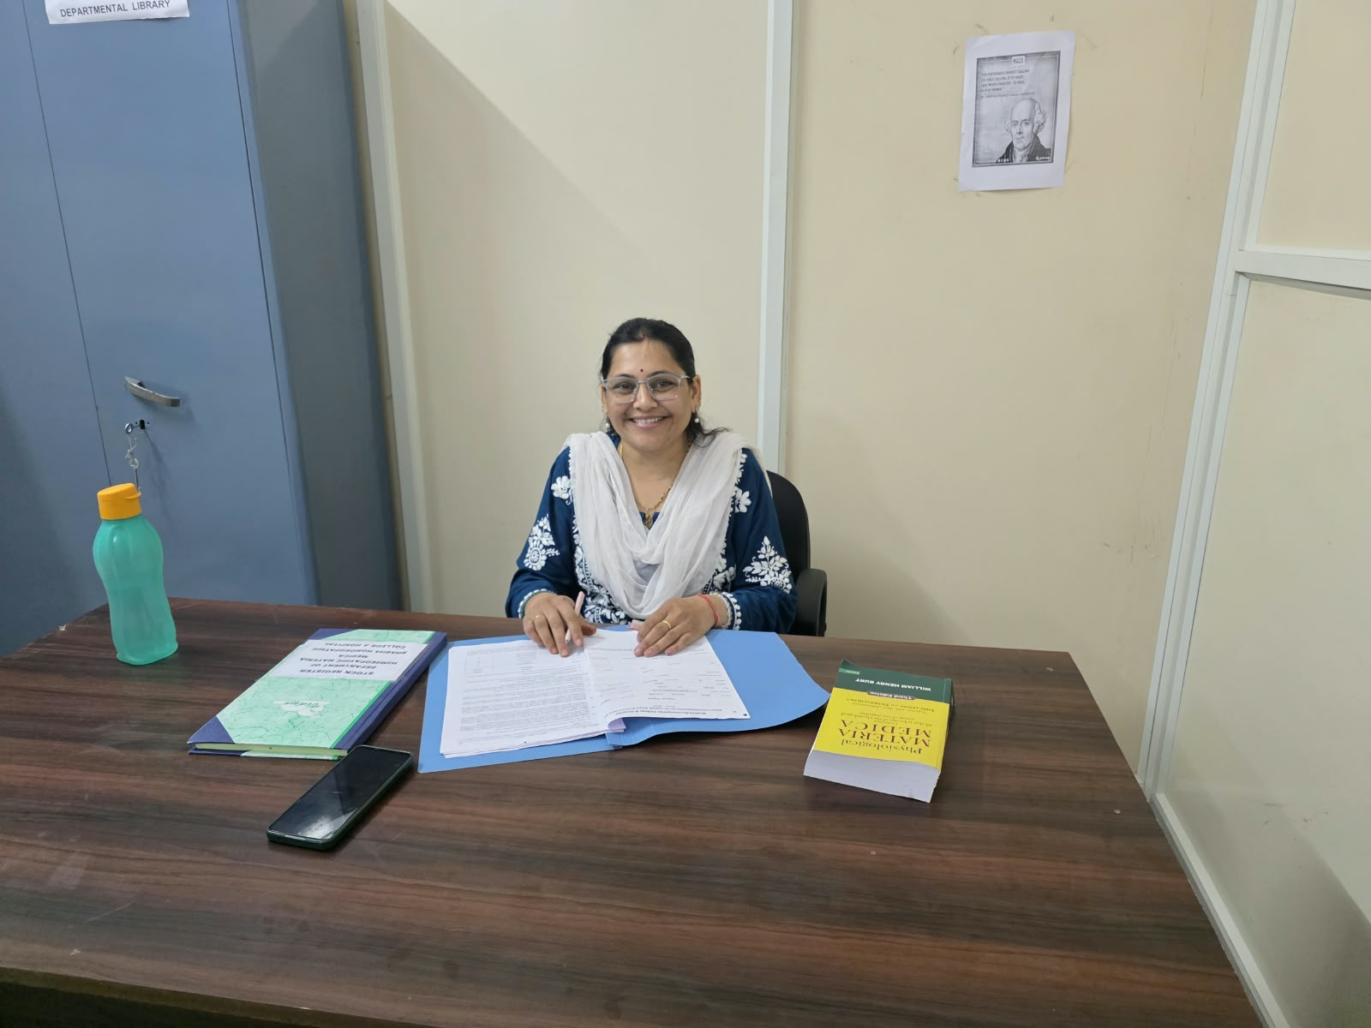
Name: Dr. Rashmi Jirapure
Designation: Professor
Qualification: BHMS, MD (HOM)
Experience: Academic Experience-15 years, Clinical Experience – 20 years

Materia Medica
Understanding Medicines Through Their Therapeutic Profiles
The Department of Homoeopathic Materia Medica focuses on the systematic study of Homoeopathic medicines and their characteristic therapeutic profiles. Students learn to understand the distinctive signs and symptoms of medicines and develop the ability to relate these profiles to individual patient presentations.

WHAT STUDENTS LEARN
Study of Homoeopathic Medicines
Students study the characteristic signs, symptoms and therapeutic indications of Homoeopathic medicines in a systematic manner.

Drug Pictures
Emphasis is placed on understanding the characteristic features of individual medicines, including their mental, general and particular symptoms.

Individualisation
Students learn to appreciate the individuality of each patient and understand the importance of selecting a medicine based on the totality of characteristic symptoms.

Comparative Study
Students develop the ability to differentiate between medicines with similar symptom pictures and recognise their distinguishing characteristics.

Clinical Correlation
Materia Medica knowledge is correlated with clinical cases to help students understand the practical application of medicines in patient care.

MATERIA MEDICA IN PRACTICE
Study | Compare | Analyse | Apply
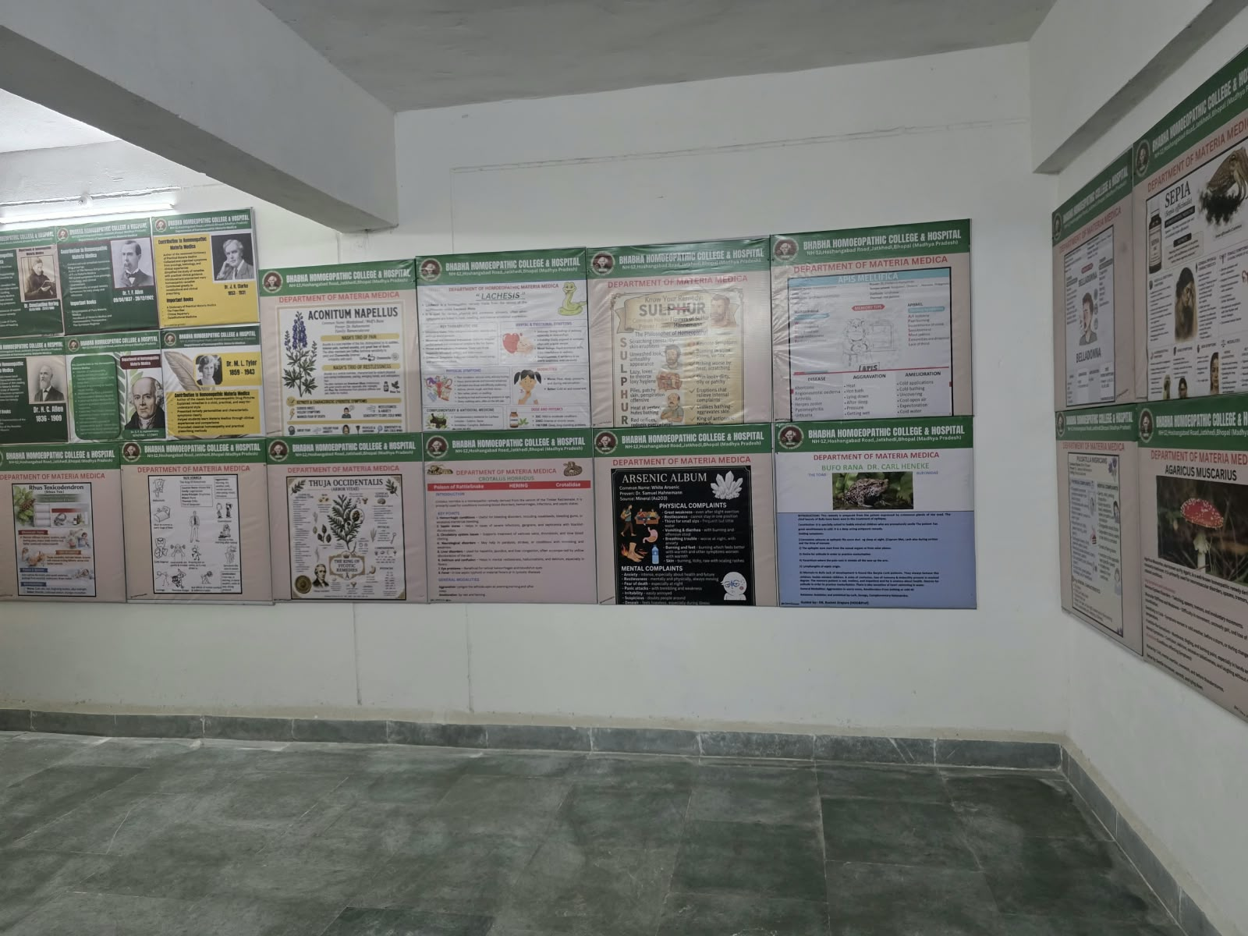

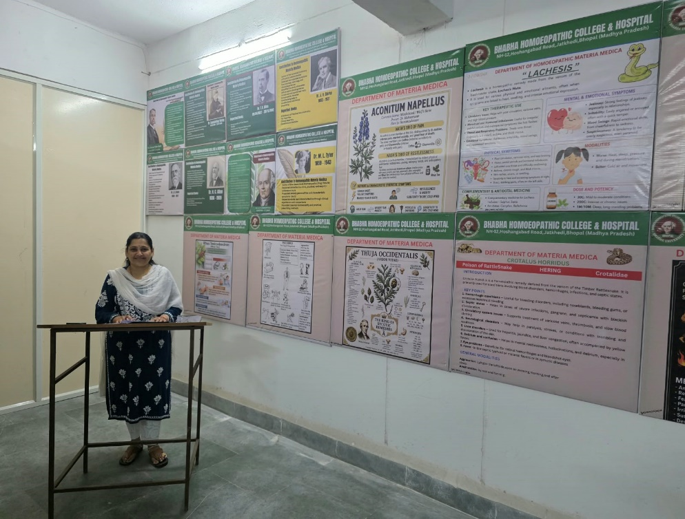

- DEPARTMENT OF ORGANON OF MEDICINE

Faculty of Organon
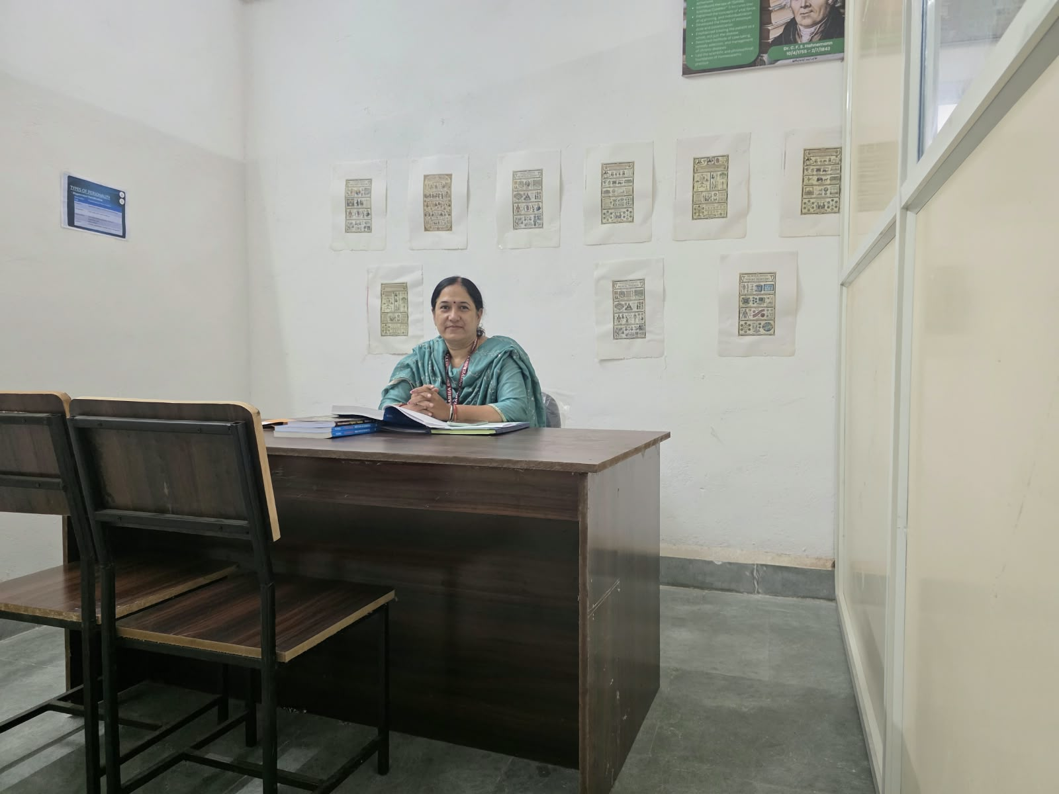
Name: Dr. Prachi Vyas
Designation: Professor
Qualification: BHMS, MD (HOM)
Experience: Academic Experience-20 years, Clinical Experience – 25 years
Research & Publication: Two write-up in Free Press Journal, Indore.

Organon of Medicine
Understanding the Principles and Practice of Homoeopathy
The Department of Organon of Medicine focuses on the fundamental principles, philosophy and methodology of Homoeopathy. The department helps students develop a clear understanding of the principles that guide Homoeopathic practice and their application in patient care.

WHAT STUDENTS LEARN
Fundamental Principles of Homoeopathy
Students study the fundamental principles and concepts that form the foundation of Homoeopathic medicine.

Principles of Cure
The department introduces students to the principles governing the selection and application of Homoeopathic treatment.

Case Taking and Individualisation
Students learn the importance of systematic case taking, careful observation and understanding the individuality of each patient.

Totality of Symptoms
Emphasis is placed on understanding the totality of characteristic symptoms and its importance in clinical decision-making.

Potentisation and Posology
Students develop an understanding of the principles of potentisation, selection of potency, repetition of doses and other aspects of Homoeopathic posology.

Physician and Patient
The department also emphasises the physician's role, professional conduct, observation and communication in the therapeutic process.

PRACTICAL AND CLINICAL LEARNING
Theoretical concepts are reinforced through case discussions, demonstrations and clinical correlation. Students are encouraged to apply the principles of Organon while observing and analysing individual patient presentations.

CASE TAKING AND CLINICAL CORRELATION
Students are introduced to systematic case taking and the process of analysing a patient's characteristic symptoms. This helps them connect the principles studied in Organon with clinical learning and the study of Materia Medica and Repertory.

OUR APPROACH
The department aims to develop thoughtful and observant practitioners who understand the principles of Homoeopathy and are able to apply them with discipline, empathy and professional responsibility.

LEARNING THROUGH ORGANON
Principles | Observe | Analyse | Individualise | Apply

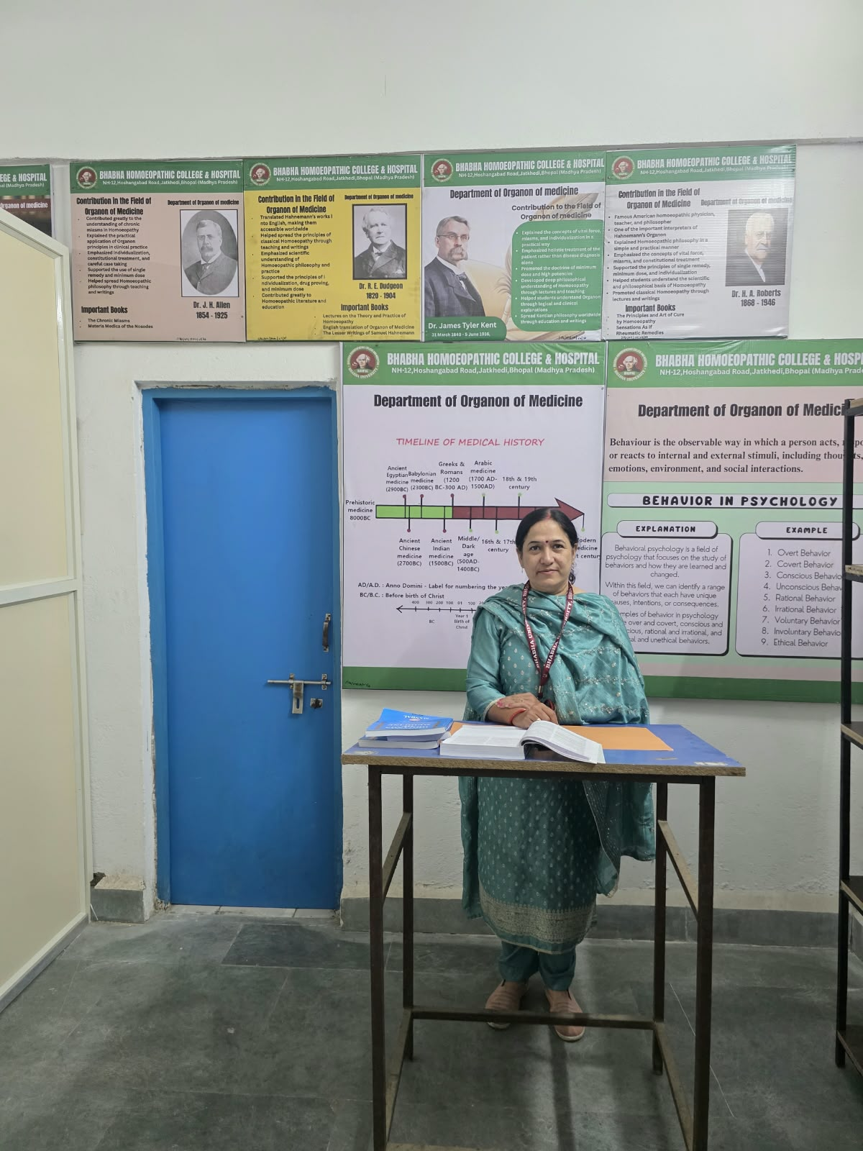

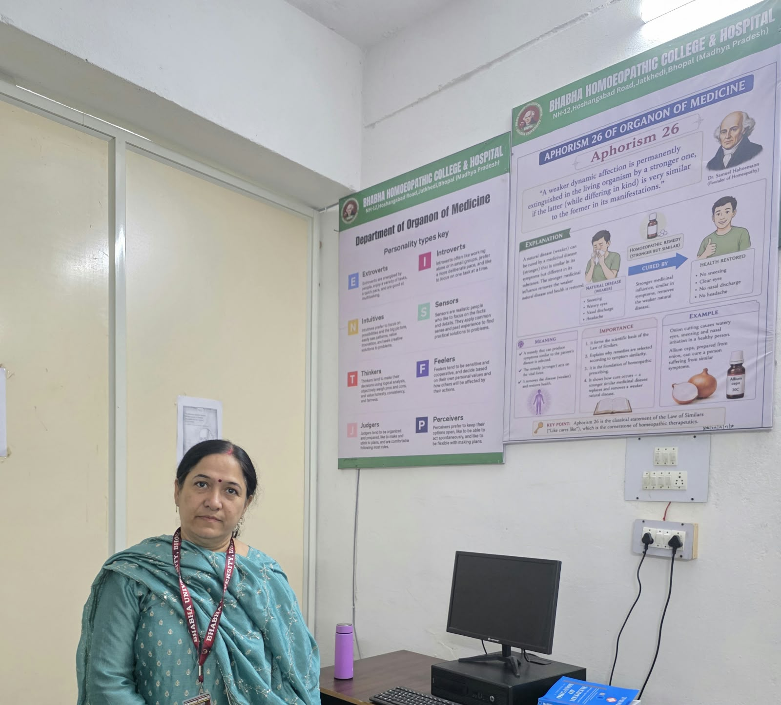

- DEPARTMENT OF REPERTORY

Faculty of Repertory
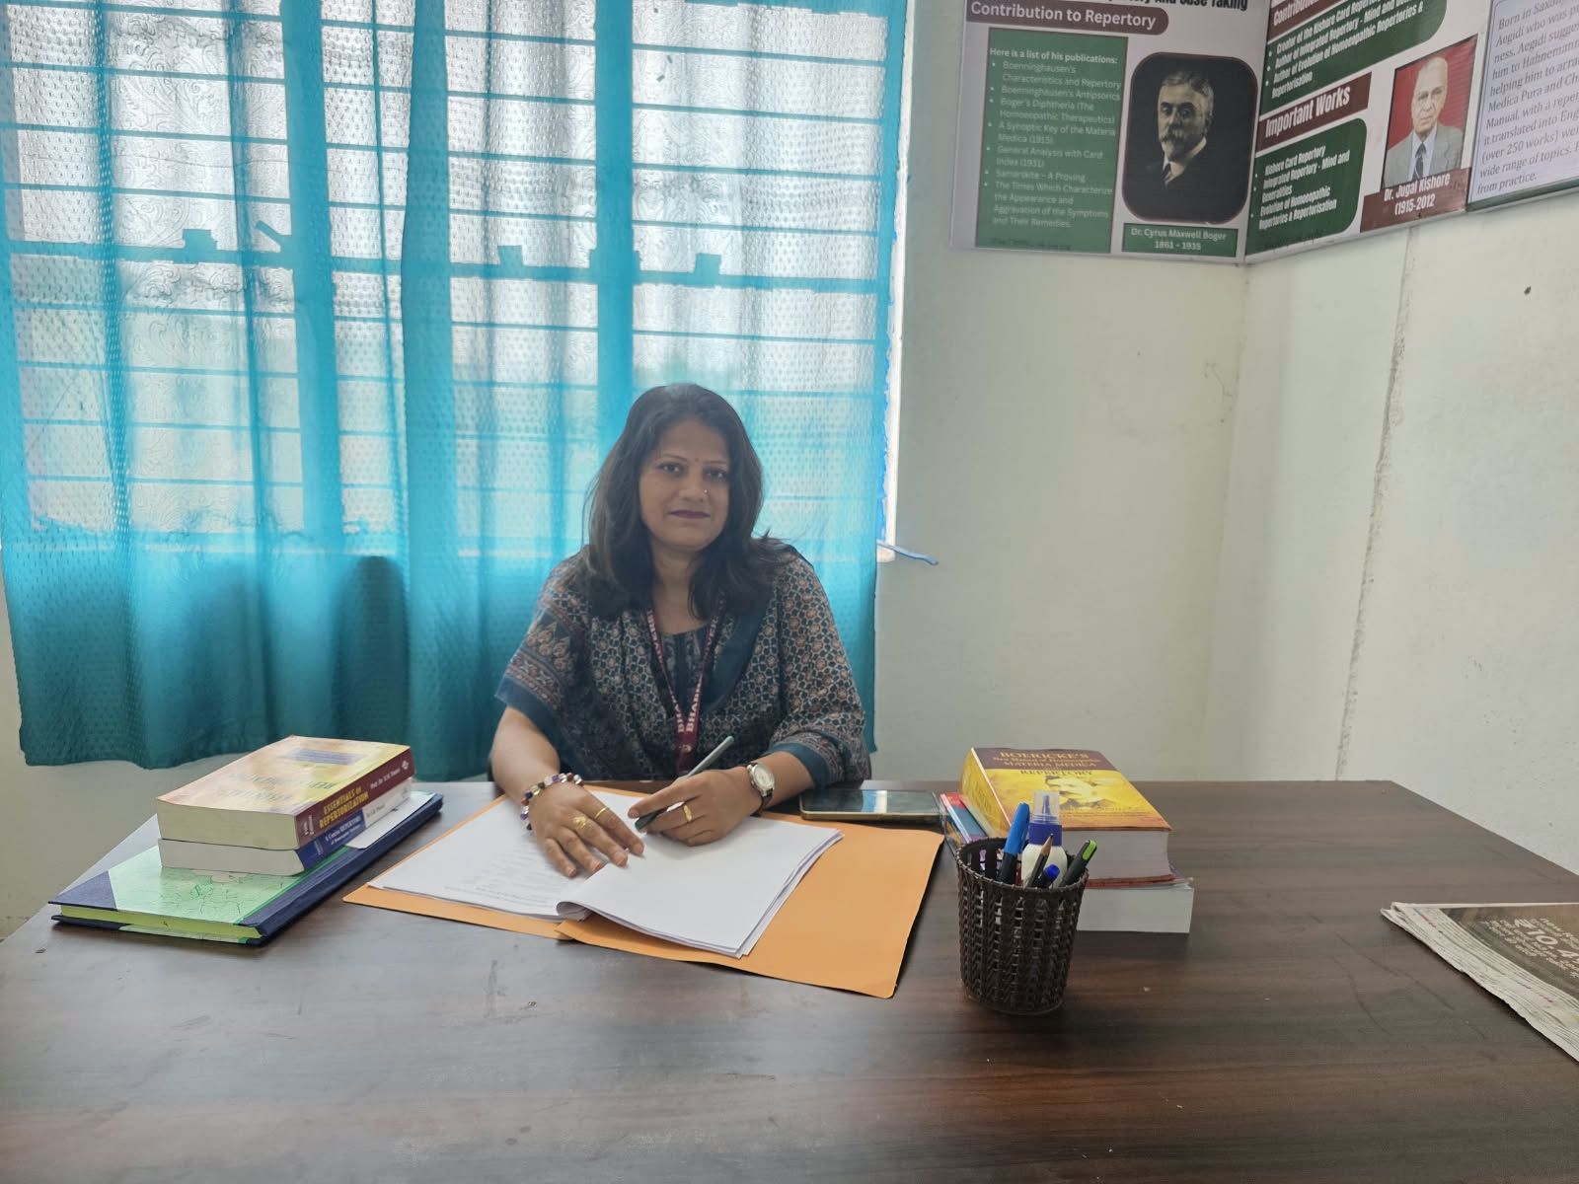
Name: Dr. Sushma Singh Patel
Designation: Professor
Qualification: BHMS, MD (HOM), PhD.
Experience: Academic Experience-9 years, Clinical Experience – 9 years
Research & Publication: Clinical Utility of Dr. J.T.Kent Repertory in Management of Hypothyroidism.

Repertory
Systematic Analysis of Symptoms for Individualised Care
The Department of Repertory focuses on the systematic analysis and evaluation of symptoms to assist in the selection of an appropriate Homoeopathic medicine. The department helps students develop the skills required to organise, analyse and interpret the totality of symptoms in an individual case.

WHAT STUDENTS LEARN
Fundamentals of Repertory
Students are introduced to the principles, structure and methodology of Homoeopathic Repertory and its role in clinical practice.

Case Analysis
Students learn to analyse the symptoms obtained through systematic case taking and identify the characteristic features of a case.

Repertorisation
Students develop practical skills in repertorisation and learn to use appropriate repertories as tools for systematic analysis of cases.

Understanding Rubrics
Emphasis is placed on understanding, selecting and interpreting appropriate rubrics from the patient's symptoms.

Comparative Evaluation
Students learn to compare the results of repertorisation with Materia Medica to arrive at a well-considered medicine selection.

Clinical Correlation
Repertory is studied in conjunction with Organon of Medicine and Materia Medica, helping students understand its practical application in clinical cases.

PRACTICAL AND CLINICAL LEARNING
The department emphasises practical case analysis, repertorisation exercises and case discussions. Students are encouraged to develop a systematic approach to symptom evaluation and to use repertory as an aid to clinical reasoning rather than as a substitute for comprehensive case understanding.

CASE TAKING AND REPERTORISATION
Students learn to progress from systematic case taking to symptom analysis, selection of appropriate rubrics, repertorisation and comparison with Materia Medica.

OUR APPROACH
The department aims to develop students' analytical and clinical reasoning skills and help them use repertory effectively as part of a comprehensive and individualised approach to Homoeopathic case management.

LEARNING THROUGH REPERTORY
Observe | Analyse | Repertorise | Compare | Apply

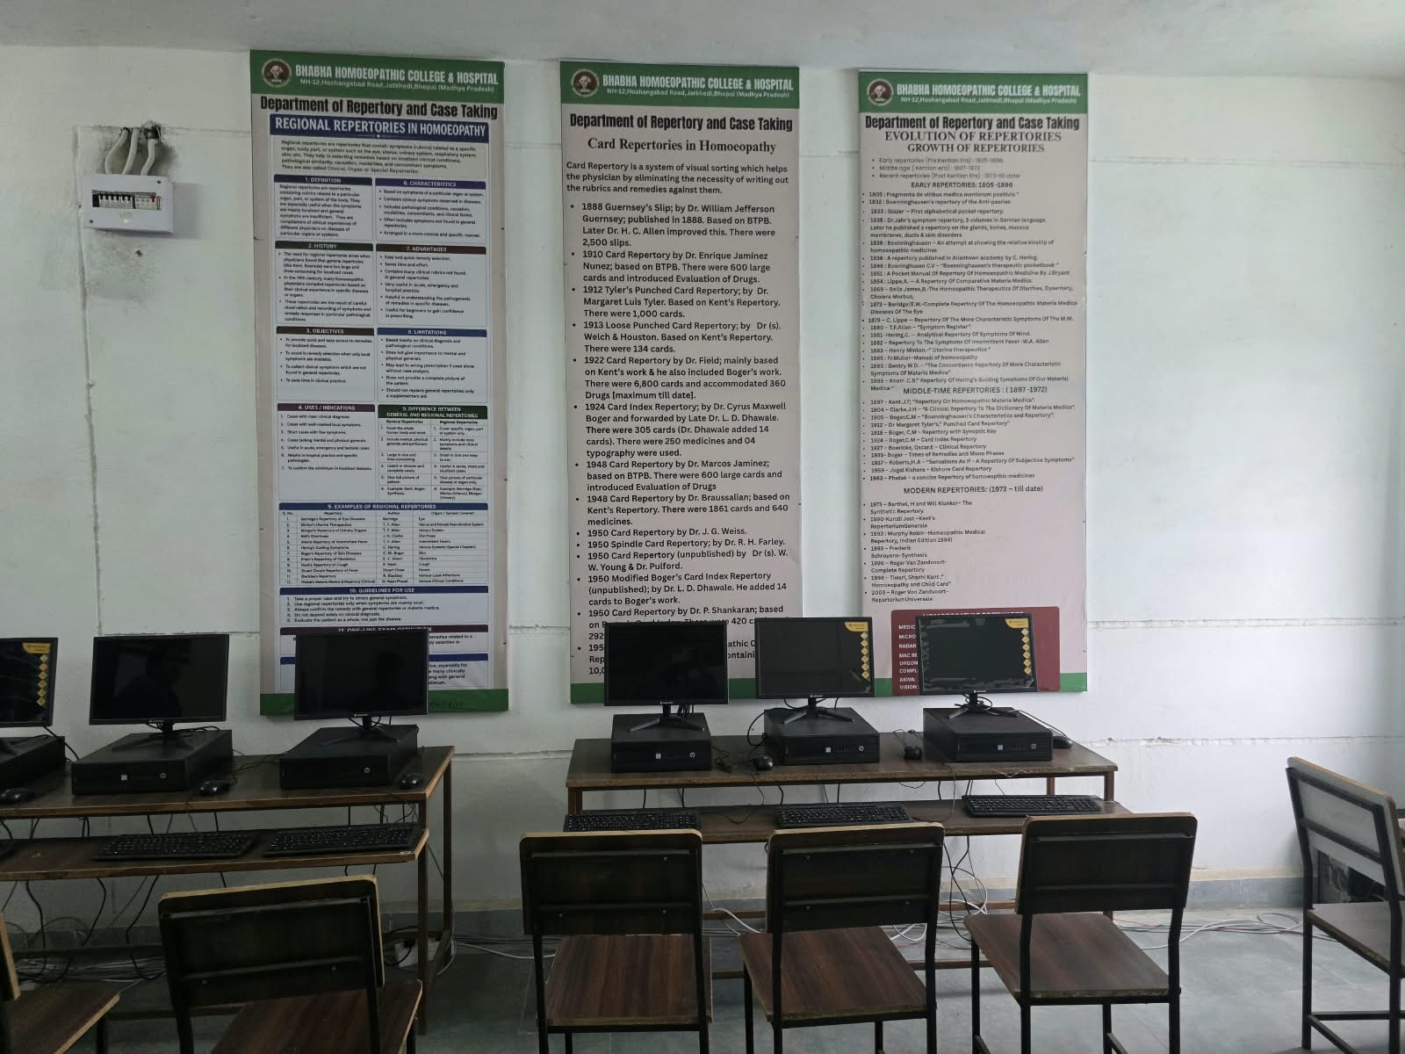

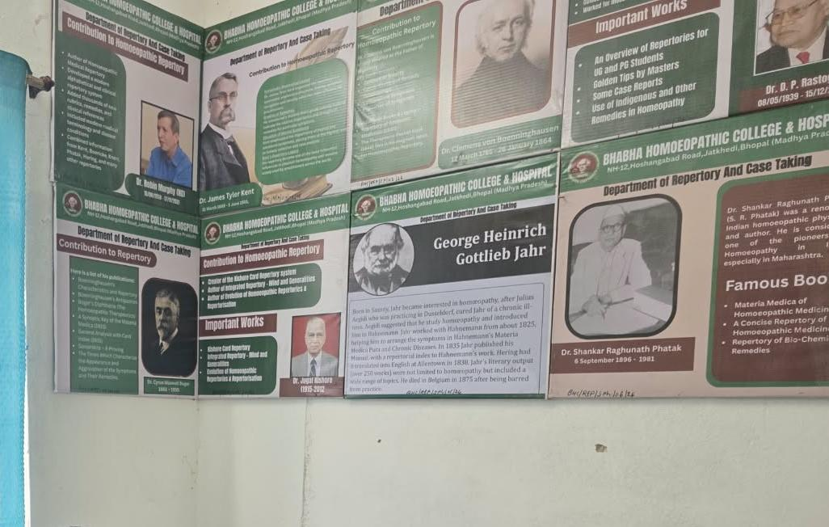

Next Tab
ADMISSIONS
Dropdown list consist of
- Eligibility
- Admission Process
- Documents Required
- Fee Structure

BHMS ELIGIBILITY CRITERIA
Eligibility for Admission to BHMS – 2026–27
Candidates seeking admission to the Bachelor of Homoeopathic Medicine and Surgery (BHMS) programme must fulfil the eligibility requirements prescribed by the National Commission for Homoeopathy (NCH), National Testing Agency (NTA) and the competent counselling authorities.

ACADEMIC QUALIFICATION
Candidates must have passed 10+2 or an equivalent examination from a recognised Board with:
* Physics
* Chemistry
* Biology

MINIMUM PCB MARKS
General Category:
Minimum 50% marks taken together in Physics, Chemistry and Biology.
SC / ST / OBC Categories:
Minimum 40% marks taken together in Physics, Chemistry and Biology.
Specified Disability – General Category:
Minimum 45% marks in Physics, Chemistry and Biology.
Specified Disability – SC / ST / OBC:
Minimum 40% marks in Physics, Chemistry and Biology.

AGE REQUIREMENT
The candidate must have attained 17 years of age on or before 31 December of the year of admission.

NEET-UG REQUIREMENT
Qualification in NEET-UG is mandatory for admission to BHMS.
For NEET-UG 2026, the qualifying criteria are:
General / EWS:
50th percentile
SC / ST / OBC:
40th percentile
Specified Disability – General / EWS:
45th percentile
Specified Disability – SC / ST / OBC:
40th percentile

NEET-UG 2026 QUALIFYING MARKS
General / EWS:
213 marks or above
OBC / SC / ST:
177 marks or above
PwBD candidates:
Category-specific qualifying marks as prescribed by NTA.

IMPORTANT NOTE
Qualifying NEET-UG does not by itself guarantee admission to a particular college.
Admission to BHMCH will be subject to the applicable counselling process, merit, seat availability, category, eligibility and the rules prescribed by the competent authorities for the academic session 2026–27.
Candidates are advised to verify the latest counselling notifications and admission instructions before completing the admission process.

NEXT DROPDOWN LIST

Admission Process for BHMS – 2026–27
Admission to the Bachelor of Homoeopathic Medicine and Surgery (BHMS) programme is conducted in accordance with the regulations of the National Commission for Homoeopathy (NCH), NEET-UG requirements and the counselling procedure prescribed by the competent authority.
The admission process follows a merit-based counselling system and eligible candidates are required to participate through the appropriate counselling authority.
Seat Quota Distribution:
15% Seats: All-India Quota (AIQ) filled via central counseling (such as AACCC).
85% Seats: State/UT Quota filled via respective state counseling authorities.
Counseling Registration: Register on the designated central or state AYush counseling portal during active counseling windows.

STEP 1 — APPEAR FOR NEET-UG
Candidates seeking admission to BHMS must appear for NEET-UG and fulfil the applicable qualifying criteria.
NEET-UG qualification is mandatory for admission to BHMS.

STEP 2 — CHECK ELIGIBILITY
Candidates should ensure that they fulfil the prescribed:
* Academic qualifications
* PCB subject requirements
* Minimum qualifying marks
* Age requirement
* NEET-UG qualifying criteria
* Other applicable eligibility conditions

STEP 3 — REGISTER FOR COUNSELLING
After qualifying NEET-UG, eligible candidates must register for the counselling process conducted by the competent authority applicable to the relevant category of seats.
For private Homoeopathic institutions, candidates should follow the counselling instructions issued by the concerned State/UT counselling authority, as applicable.

STEP 4 — CHOOSE THE COLLEGE
During counselling, candidates can select their preferred institutions and courses from the participating colleges available to them according to the applicable counselling rules.
Candidates should carefully check the available BHMS seats, fee structure and other relevant information before submitting and locking their choices.

STEP 5 — SEAT ALLOTMENT
Seats are allotted on the basis of:
* NEET-UG merit
* Candidate's eligibility
* Category and applicable reservation provisions
* Choices submitted by the candidate
* Seat availability
* Counselling rules applicable to the relevant authority

STEP 6 — DOWNLOAD THE ALLOTMENT LETTER
Candidates who are allotted a BHMS seat should download the provisional/seat allotment document generated through the official counselling portal and follow the instructions provided.

STEP 7 — REPORT TO THE ALLOTTED INSTITUTION
The candidate must report to the allotted college within the prescribed time period and complete the admission formalities.
Candidates should carry the required original documents and their prescribed copies for verification.

STEP 8 — DOCUMENT VERIFICATION
The college verifies the documents submitted by the candidate as prescribed by the competent counselling authority.

Documents may include:
* NEET-UG Admit Card
* NEET-UG Score Card / Result
* Seat Allotment Letter
* Class 10 Certificate and Marksheet
* Class 12 Certificate and Marksheet
* Transfer Certificate
* Migration Certificate, wherever applicable
* Valid Identity Proof
* Passport-size Photographs
* Category Certificate, wherever applicable
* EWS Certificate, wherever applicable
* PwBD Certificate, wherever applicable
* Medical Fitness Certificate
* Other documents prescribed by the counselling authority

STEP 9 — COMPLETE ADMISSION FORMALITIES
After successful verification, the candidate must complete the remaining admission formalities, including payment of applicable fees and submission of required documents, within the prescribed timeline.

STEP 10 — BEGIN YOUR BHMS JOURNEY
Once the admission process is successfully completed, students can begin their academic journey at Bhabha Homoeopathic Medical College & Hospital.

IMPORTANT COUNSELLING INFORMATION
* Admission to BHMS is through the prescribed counselling process only.
* Direct admission outside the prescribed counselling system is not permitted.
* Candidates must follow the latest instructions issued by the competent counselling authority.
* Candidates should regularly check the official counselling portal for registration dates, seat matrix, choice filling, allotment results and reporting schedules.
* Merely qualifying NEET-UG does not guarantee admission to a particular college.
* Admission is subject to eligibility, merit, seat availability and the applicable counselling rules.

FOR BHABHA HOMOEOPATHIC MEDICAL COLLEGE & HOSPITAL
Candidates interested in BHMCH should select the college as a preferred institution during the applicable counselling process, subject to the availability of seats and the rules of the concerned counselling authority.
For information regarding college facilities, fee structure, documents, campus visits and other institutional queries, candidates may contact the BHMCH Admission Office.

[ENQUIRE NOW]
[CONTACT ADMISSION OFFICE]

NEXT DROPDOWN LIST

Documents Required
To finalize your admission into a Bachelor of Homeopathic Medicine and Surgery (BHMS) course regulated by the National Commission for Homoeopathy (NCH), you must present original documents at your allotted college.
The Ayush Admissions Central Counseling Committee (AACCC) advises carrying the original papers along with at least two sets of self-attested photocopies.

NEET & Counselling Documents
Provisional Allotment Letter: Generated from the central (AACCC) or respective state counseling portal.
NEET-UG Admit Card: Issued by the National Testing Agency (NTA).
NEET-UG Scorecard / Rank Letter: Showing your qualified NEET marks and All India Rank.

Academic Certificates
Class 10 Marksheet & Passing Certificate: Serves as official proof of your date of birth.
Class 12 Marksheet & Passing Certificate: Verifies your aggregate marks in Physics, Chemistry, Biology, and English.
Transfer Certificate (TC) / School Leaving Certificate: From the last academic institution you attended.
Migration Certificate: Required if you are shifting from a different school board or university.
Character Certificate: Issued by your previous school or college principal.

Identity & Personal Records
Passport-Size Photographs: Bring 8 to 12 recent photos, ideally identical to the one uploaded on your NEET application form.
Valid Photo ID Proof: Government-issued identity such as an Aadhaar Card, PAN Card, Passport, or Driving License.
Medical Fitness Certificate: Issued by a Registered Medical Practitioner in the prescribed format certifying your physical health.
Reserved Category & Special Certificates (If Applicable)
Caste / Category Certificate: Required for SC, ST, or OBC-NCL candidates. OBC certificates must follow the specified central or state government format.
EWS Certificate: An Income and Asset Certificate for Economically Weaker Sections issued for the current financial year.
PwD Certificate: Persons with Disabilities certificate from an authorized medical board.
Domicile Certificate: Compulsory if you are taking admission through the 85% State Quota seats.
Gap Year Affidavit: A notarized document explaining the timeline if there is a gap between your Class 12 completion and the current admission year.

Link to nch official website
Link to AACCC official counselling portal

Next tab
HOSPITAL
Dropdown list
About Our Hospital
OPD Services
IPD Services
Clinical Departments
Homoeopathic Medicine
Homoeopathic Surgery
Obstetrics & Gynaecology
Paediatrics
Diagnostic Services
Homoeopathic Pharmacy
Nursing & Patient Care
Patient Counselling
Dietary Services
Clinical Facilities
Hospital at a Glance
Hospital Gallery
Contact / OPD Information

Ist dropdown list
ABOUT OUR HOSPITAL

BHABHA HOMOEOPATHIC TEACHING HOSPITAL
A Centre for Patient Care, Clinical Education and Professional Learning
Bhabha Homoeopathic Medical College & Hospital is supported by an attached teaching hospital that provides patient care while serving as an important centre for clinical education and practical training.
The hospital provides an environment where healthcare delivery and medical education come together. Students gain clinical exposure through interaction with patients and observation of clinical conditions under the guidance of faculty, helping them connect their academic knowledge with practical experience.

Our approach focuses on patient-centred care, respectful communication, clinical observation and responsible healthcare practices.

HOSPITAL SERVICES
The hospital provides facilities for outpatient and inpatient care through various clinical departments, including:

* Homoeopathic Medicine
* Homoeopathic Surgery
* Obstetrics & Gynaecology
* Paediatrics

OPD CARE
The Outpatient Department provides consultation and follow-up services for patients attending the hospital.

Students may gain supervised clinical exposure through:
* Patient History Taking
* Clinical Observation
* Case Taking
* General Examination
* Case Analysis
* Repertorisation
* Patient Counselling
* Follow-up of Patients

INPATIENT CARE
The hospital provides inpatient facilities for patients requiring admission and supervised care.
The IPD environment provides students with opportunities to observe patient management, clinical progress and follow-up under the guidance of faculty.

SUPPORTIVE SERVICES
The hospital is supported by essential facilities and services that contribute to patient care and clinical education, including:
* Diagnostic Services
* Homoeopathic Pharmacy
* Nursing Care
* Dietary Support
* Patient Counselling

A TEACHING ENVIRONMENT
As a teaching hospital, Bhabha provides an environment where students can progressively develop clinical skills and professional confidence.
Through supervised clinical exposure, students learn to communicate with patients, understand clinical presentations, apply their knowledge and appreciate the responsibilities of healthcare professionals.

PATIENT CARE WITH COMPASSION
We believe that quality healthcare begins with listening, understanding and treating every patient with dignity and respect.
Our hospital strives to provide a supportive environment for patients while contributing to the education and professional development of future healthcare practitioners.

HOSPITAL AT A GLANCE

300+ - OPD PATIENTS / DAY
Serving patients through outpatient care

25+ - IPD BED OCCUPANCY
Inpatient care and clinical supervision

04 - CLINICAL DEPARTMENTS
Medicine | Surgery | Gynaecology | Paediatrics

OPD + IPD - INTEGRATED PATIENT CARE
Outpatient and inpatient services

TEACHING HOSPITAL - CLINICAL LEARNING
Supporting practical and clinical education

ESSENTIAL SUPPORT SERVICES
Diagnostics | Pharmacy | Nursing | Dietary Support | Patient Counselling

Next dropdown list

